# Sites that were included

NSABHC0002 Test Set: (Timestamp('2017-11-10 00:00:00'), Timestamp('2020-03-07 00:00:00')), Period: 82  
  
NSABHC0011 Test Set: (Timestamp('2009-03-01 00:00:00'), Timestamp('2012-04-18 00:00:00')), Period: 88  
  
NSABHC0016 Test Set: (Timestamp('2020-01-27 00:00:00'), Timestamp('2022-12-26 00:00:00')), Period: 84  
  
NSABHC0022 Test Set: (Timestamp('2020-04-16 00:00:00'), Timestamp('2022-12-27 00:00:00')), Period: 162  
  
NSAMDD0004 Test Set: (Timestamp('2012-02-23 00:00:00'), Timestamp('2015-04-20 00:00:00')), Period: 78  
  
NSAMDD0006 Test Set: (Timestamp('2005-10-17 00:00:00'), Timestamp('2008-10-18 00:00:00')), Period: 152  
  
NSAMDD0012 Test Set: (Timestamp('1993-10-30 00:00:00'), Timestamp('1998-11-30 00:00:00')), Period: 75  
  
NTAFIN0028 Test Set: (Timestamp('2018-01-15 00:00:00'), Timestamp('2020-04-26 00:00:00')), Period: 87  
  
NTASSD0013 Test Set: (Timestamp('1999-07-15 00:00:00'), Timestamp('2004-02-11 00:00:00')), Period: 94  
  
NTASSD0016 Test Set: (Timestamp('1987-09-16 00:00:00'), Timestamp('1994-04-28 00:00:00')), Period: 92  
  
SAABHC0002 Test Set: (Timestamp('2020-06-02 00:00:00'), Timestamp('2022-12-26 00:00:00')), Period: 153  
  
SAABHC0005 Test Set: (Timestamp('2012-04-25 00:00:00'), Timestamp('2015-08-09 00:00:00')), Period: 154  
  
SAABHC0006 Test Set: (Timestamp('2005-09-30 00:00:00'), Timestamp('2008-09-30 00:00:00')), Period: 155  
  
SAAFLB0031 Test Set: (Timestamp('1992-09-15 00:00:00'), Timestamp('1998-02-20 00:00:00')), Period: 163  
  
SAAGAW0002 Test Set: (Timestamp('1998-08-31 00:00:00'), Timestamp('2003-07-12 00:00:00')), Period: 134  
  
SAAGAW0006 Test Set: (Timestamp('2009-03-29 00:00:00'), Timestamp('2012-07-19 00:00:00')), Period: 86  
  
SAAGAW0007 Test Set: (Timestamp('2006-07-03 00:00:00'), Timestamp('2009-04-06 00:00:00')), Period: 87  
  
SAAGAW0008 Test Set: (Timestamp('2020-08-02 00:00:00'), Timestamp('2022-12-30 00:00:00')), Period: 82  
  
SAAGVD0001 Test Set: (Timestamp('2020-07-13 00:00:00'), Timestamp('2022-12-26 00:00:00')), Period: 149  
  
SAAGVD0004 Test Set: (Timestamp('1987-09-07 00:00:00'), Timestamp('1993-07-21 00:00:00')), Period: 77  
  
SAANUL0001 Test Set: (Timestamp('2000-02-07 00:00:00'), Timestamp('2004-05-24 00:00:00')), Period: 76  
  
SAANUL0002 Test Set: (Timestamp('2003-10-20 00:00:00'), Timestamp('2006-05-21 00:00:00')), Period: 120  
  
SAANUL0004 Test Set: (Timestamp('2009-02-07 00:00:00'), Timestamp('2013-01-09 00:00:00')), Period: 122  
  
SAARIV0008 Test Set: (Timestamp('2015-09-17 00:00:00'), Timestamp('2018-02-13 00:00:00')), Period: 122  
  
SAARIV0009 Test Set: (Timestamp('1999-10-15 00:00:00'), Timestamp('2003-09-25 00:00:00')), Period: 120  
  
SAASTP0001 Test Set: (Timestamp('2004-03-14 00:00:00'), Timestamp('2006-09-04 00:00:00')), Period: 93  
  
SAASTP0003 Test Set: (Timestamp('2020-02-15 00:00:00'), Timestamp('2022-12-13 00:00:00')), Period: 93  
  
SAASTP0007 Test Set: (Timestamp('1998-11-01 00:00:00'), Timestamp('2003-03-21 00:00:00')), Period: 169  
  
SAASTP0008 Test Set: (Timestamp('1987-09-09 00:00:00'), Timestamp('1993-01-28 00:00:00')), Period: 171  
  
SAASTP0010 Test Set: (Timestamp('2016-07-30 00:00:00'), Timestamp('2019-04-17 00:00:00')), Period: 135  
  
SAASTP0014 Test Set: (Timestamp('2017-12-08 00:00:00'), Timestamp('2020-03-19 00:00:00')), Period: 91  
  
SAASTP0016 Test Set: (Timestamp('2004-02-12 00:00:00'), Timestamp('2006-07-19 00:00:00')), Period: 90  
  
SAASTP0017 Test Set: (Timestamp('2006-07-11 00:00:00'), Timestamp('2009-02-09 00:00:00')), Period: 90  
  
SAASTP0019 Test Set: (Timestamp('2004-01-27 00:00:00'), Timestamp('2006-06-25 00:00:00')), Period: 88  
  
SAASTP0021 Test Set: (Timestamp('1987-09-09 00:00:00'), Timestamp('1993-02-13 00:00:00')), Period: 90  
  
SAASTP0022 Test Set: (Timestamp('2009-03-12 00:00:00'), Timestamp('2012-12-01 00:00:00')), Period: 92  
  
SAASTP0023 Test Set: (Timestamp('2009-04-13 00:00:00'), Timestamp('2013-01-02 00:00:00')), Period: 91  
  
SAASTP0024 Test Set: (Timestamp('2012-10-14 00:00:00'), Timestamp('2015-07-19 00:00:00')), Period: 90  
  
SAASTP0025 Test Set: (Timestamp('2006-07-10 00:00:00'), Timestamp('2009-04-13 00:00:00')), Period: 90  
  
SAASTP0026 Test Set: (Timestamp('2012-09-12 00:00:00'), Timestamp('2015-05-16 00:00:00')), Period: 90  
  
SAASTP0027 Test Set: (Timestamp('1993-10-18 00:00:00'), Timestamp('1999-06-29 00:00:00')), Period: 90  
  
SAASTP0028 Test Set: (Timestamp('2009-04-05 00:00:00'), Timestamp('2013-03-07 00:00:00')), Period: 91  
  
SAASTP0029 Test Set: (Timestamp('2006-06-09 00:00:00'), Timestamp('2009-01-16 00:00:00')), Period: 89  
  
SAASTP0033 Test Set: (Timestamp('2020-04-04 00:00:00'), Timestamp('2022-12-30 00:00:00')), Period: 85  
  
SAASTP0034 Test Set: (Timestamp('2015-05-09 00:00:00'), Timestamp('2017-11-30 00:00:00')), Period: 86  
  
SASMDD0004 Test Set: (Timestamp('1994-06-11 00:00:00'), Timestamp('2000-07-06 00:00:00')), Period: 71  
  
SASMDD0011 Test Set: (Timestamp('2006-06-05 00:00:00'), Timestamp('2009-03-25 00:00:00')), Period: 73  
  
SASRIV0001 Test Set: (Timestamp('2015-08-09 00:00:00'), Timestamp('2017-11-10 00:00:00')), Period: 66  
  
SASRIV0002 Test Set: (Timestamp('2004-01-23 00:00:00'), Timestamp('2006-06-13 00:00:00')), Period: 72  
  
SATFLB0024 Test Set: (Timestamp('2015-03-16 00:00:00'), Timestamp('2017-10-31 00:00:00')), Period: 84  
  
SATSTP0002 Test Set: (Timestamp('2018-10-18 00:00:00'), Timestamp('2020-08-13 00:00:00')), Period: 129  
  
VCAMDD0001 Test Set: (Timestamp('1987-09-21 00:00:00'), Timestamp('1993-01-08 00:00:00')), Period: 74  
  
VCAMDD0002 Test Set: (Timestamp('2013-01-08 00:00:00'), Timestamp('2015-10-13 00:00:00')), Period: 73  
  
WAACAR0001 Test Set: (Timestamp('2016-07-07 00:00:00'), Timestamp('2018-08-23 00:00:00')), Period: 98  
  
WAACAR0004 Test Set: (Timestamp('2012-11-10 00:00:00'), Timestamp('2015-10-10 00:00:00')), Period: 167  
  
WAACOO0030 Test Set: (Timestamp('1999-02-08 00:00:00'), Timestamp('2003-08-06 00:00:00')), Period: 65  
  
WAADAL0003 Test Set: (Timestamp('2015-07-26 00:00:00'), Timestamp('2018-04-05 00:00:00')), Period: 84  
  
WAANUL0001 Test Set: (Timestamp('2017-10-23 00:00:00'), Timestamp('2020-05-16 00:00:00')), Period: 69  
  
WAANUL0003 Test Set: (Timestamp('1993-08-09 00:00:00'), Timestamp('1999-03-19 00:00:00')), Period: 72  
  
WAANUL0004 Test Set: (Timestamp('2003-07-21 00:00:00'), Timestamp('2005-11-15 00:00:00')), Period: 144  
  
WAANUL0008 Test Set: (Timestamp('1987-09-12 00:00:00'), Timestamp('1993-08-11 00:00:00')), Period: 75  
  
WAANUL0009 Test Set: (Timestamp('2015-03-16 00:00:00'), Timestamp('2017-09-05 00:00:00')), Period: 142  
  
WAAPIL0026 Test Set: (Timestamp('2011-12-21 00:00:00'), Timestamp('2015-05-13 00:00:00')), Period: 172  
  
WAGCOO0004 Test Set: (Timestamp('1993-01-02 00:00:00'), Timestamp('1998-09-06 00:00:00')), Period: 149

# Table: MSE of the Random Forest on each output

|  |  |  |  |  |
| --- | --- | --- | --- | --- |
|  | pv_filter | npv_filter | bs_filter | loss_mean |
| Train | 0.875 | 1.371 | 1.504 | 1.25 |
| Test | 25.097 | 37.714 | 46.236 | 36.349 |

# Permutation Importance

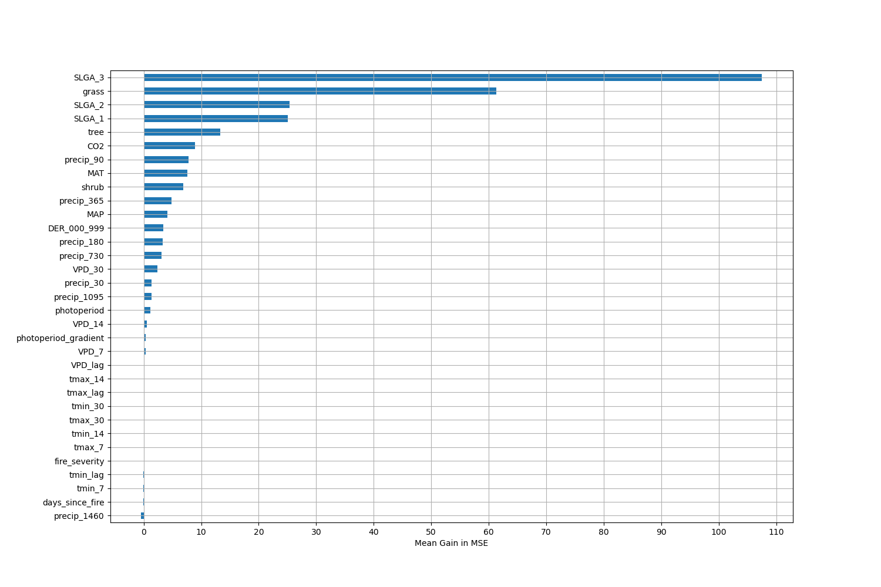

# Permutation Importance by Precip

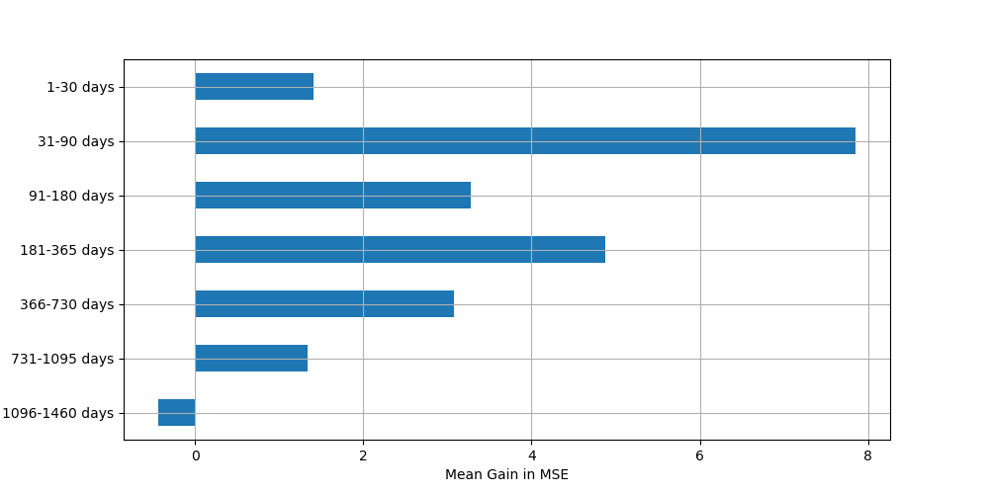

# ALE Importance

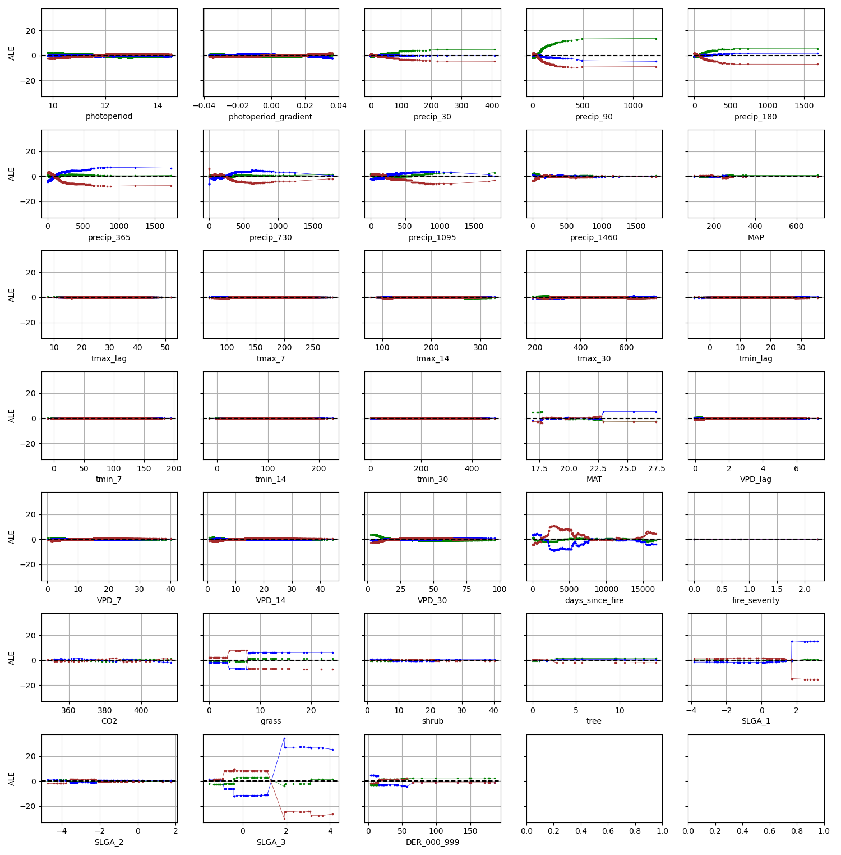

# NSABHC0002

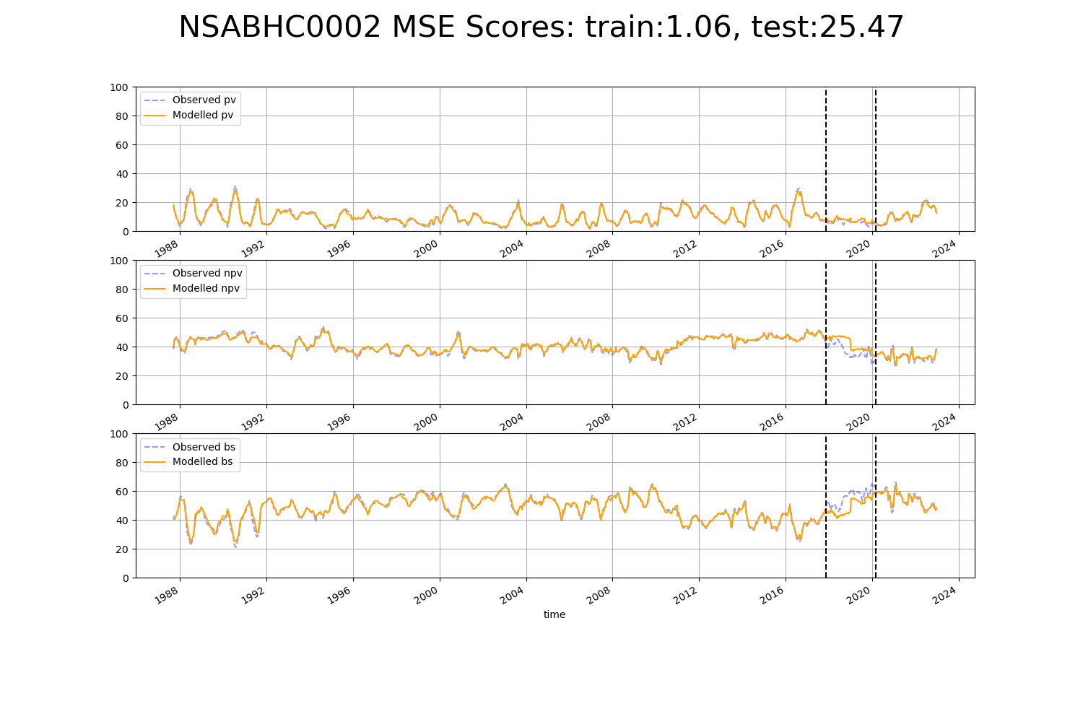

# NSABHC0011

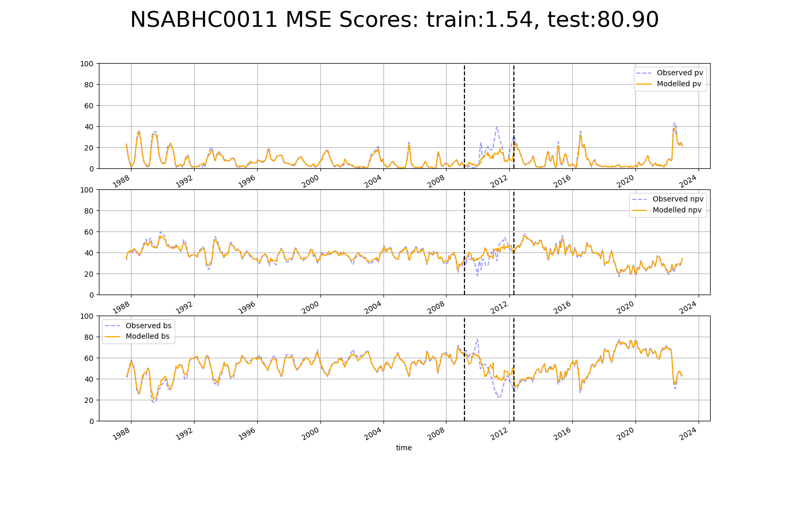

# NSABHC0016

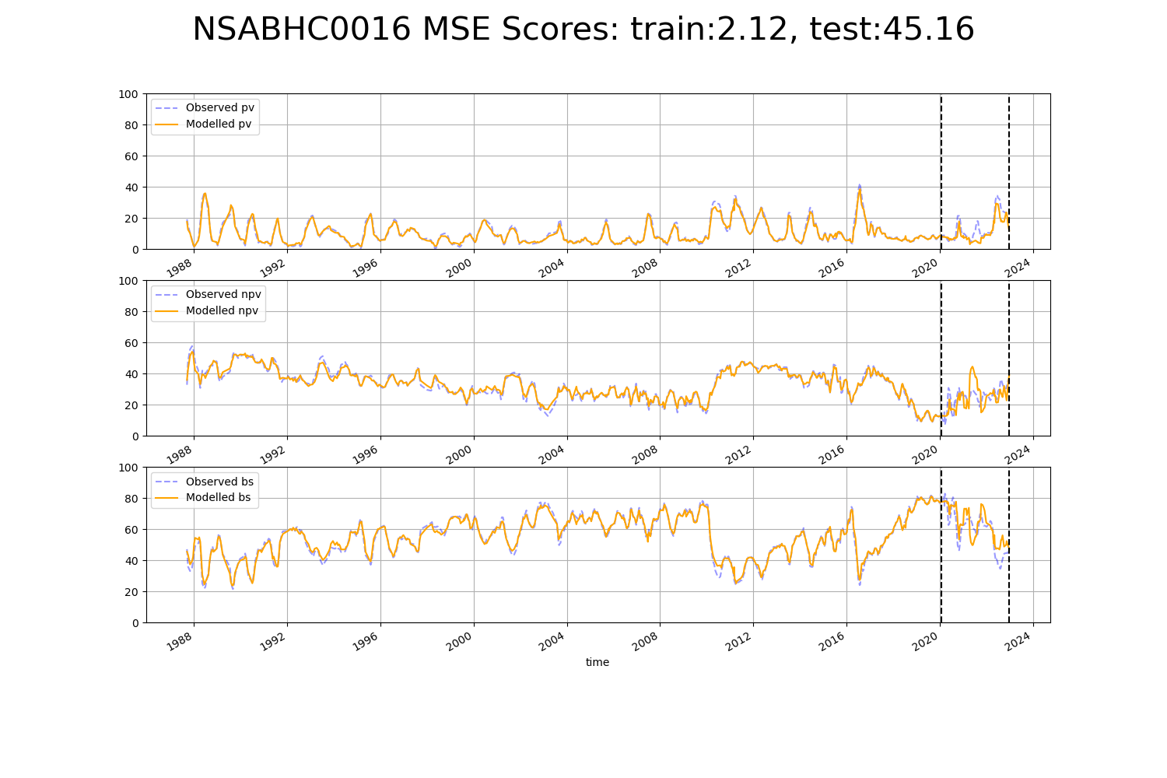

# NSABHC0022

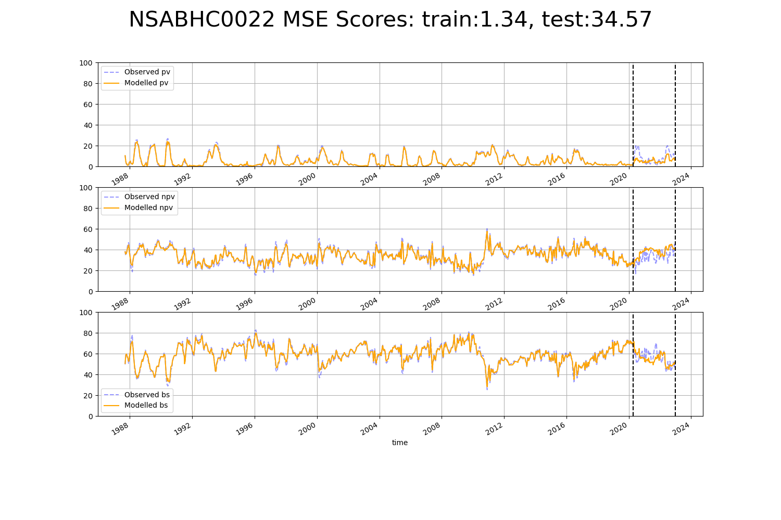

# NSAMDD0004

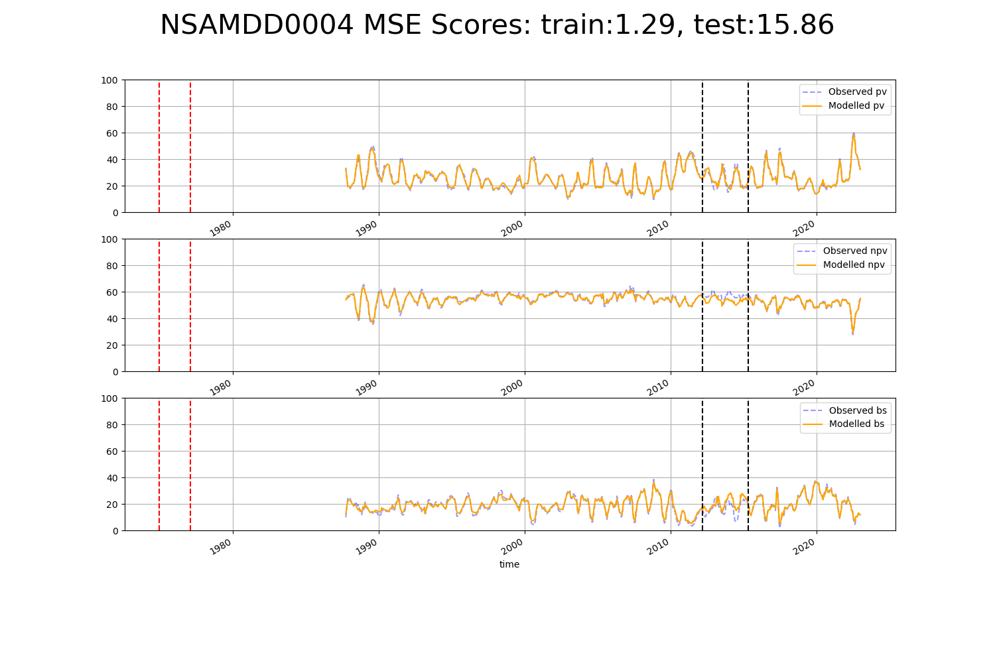

# NSAMDD0006

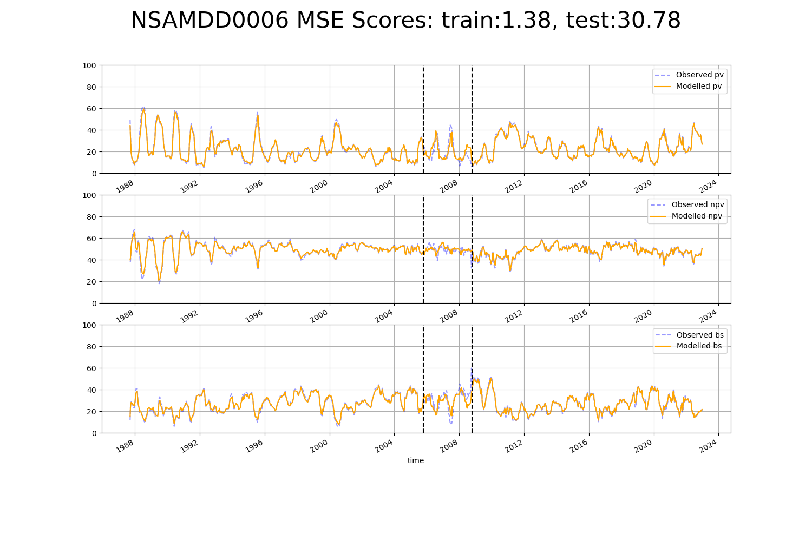

# NSAMDD0012

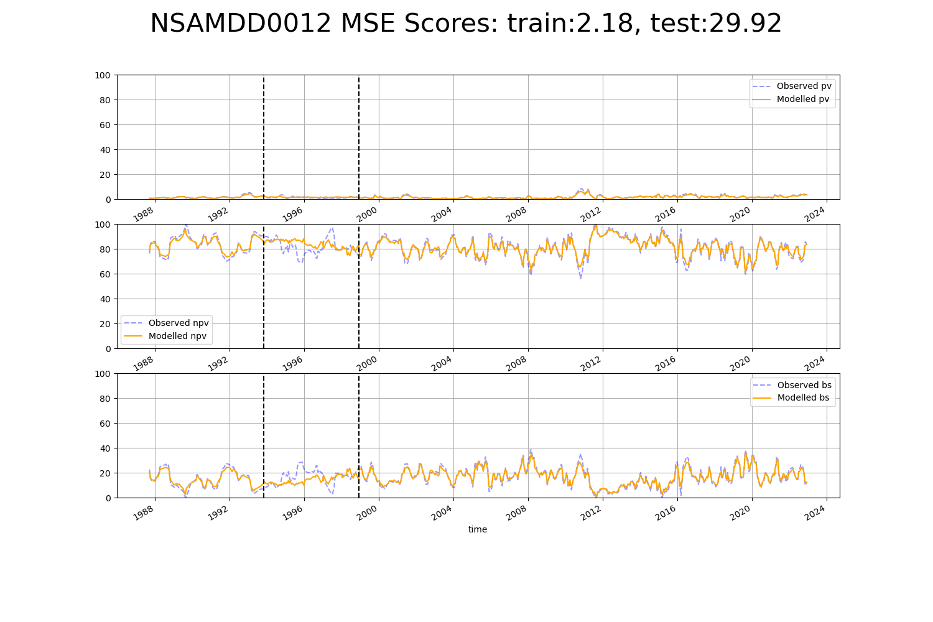

# NTAFIN0028

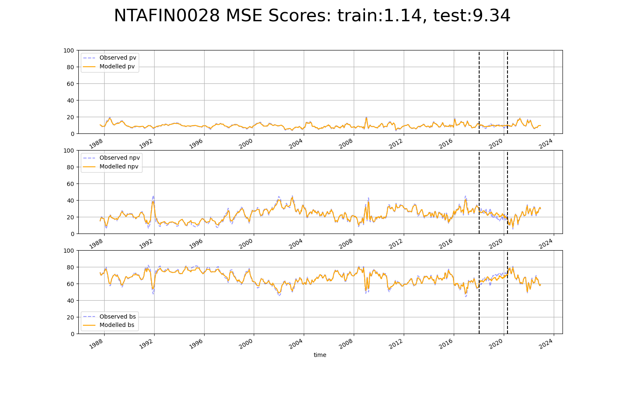

# NTASSD0013

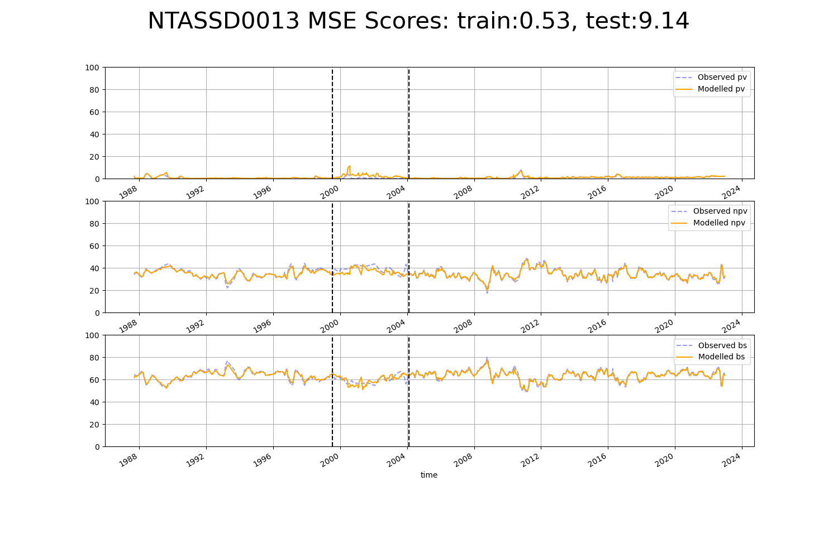

# NTASSD0016

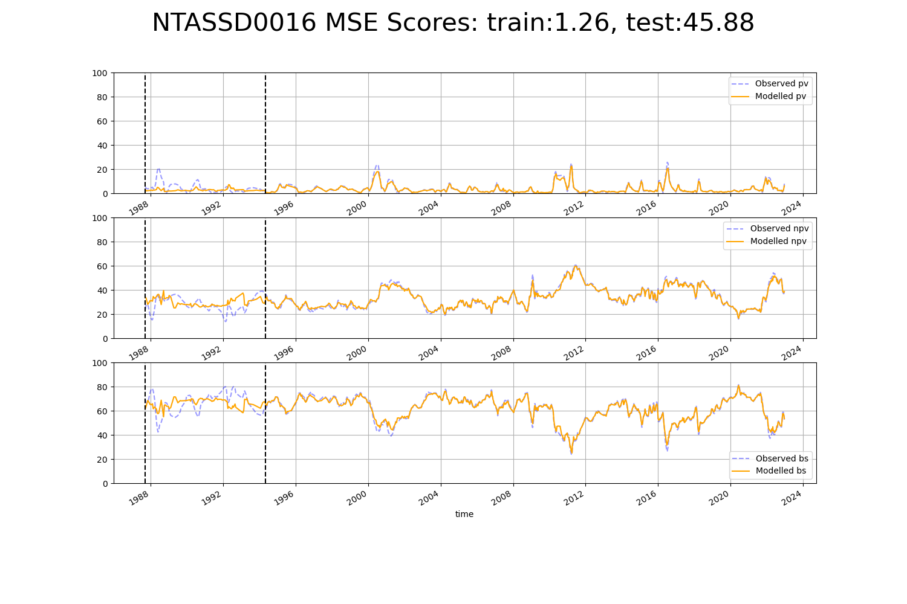

# SAABHC0002

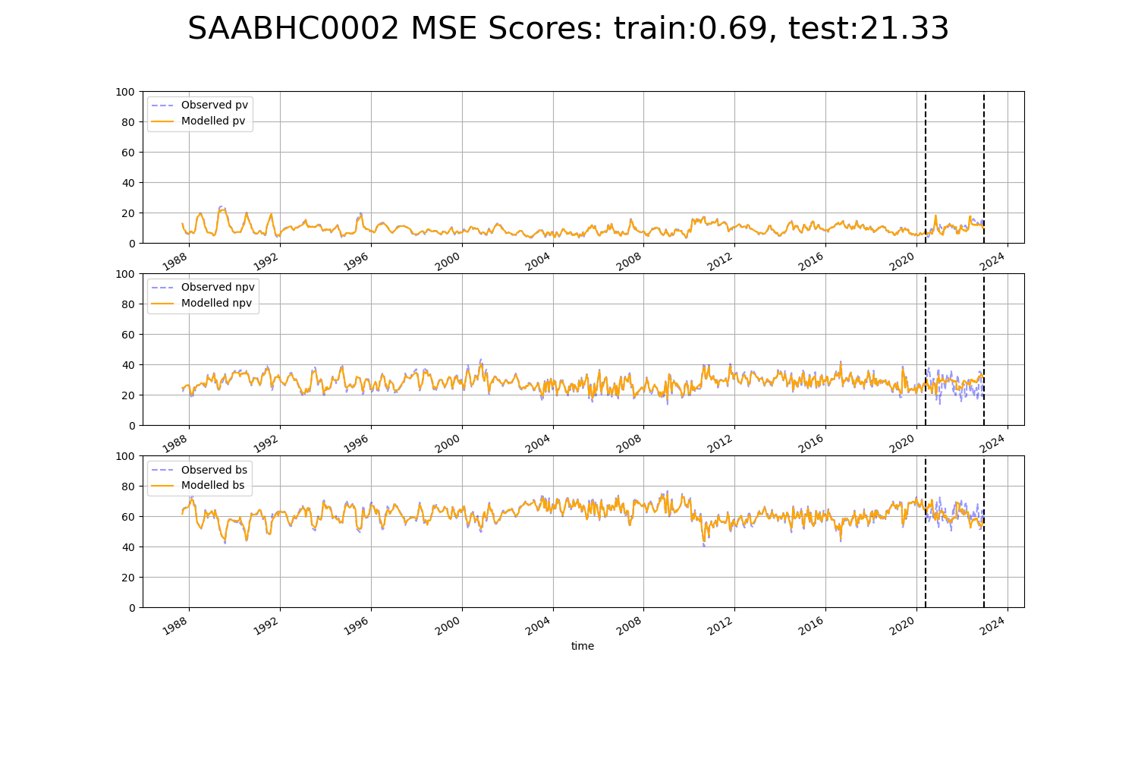

# SAABHC0005

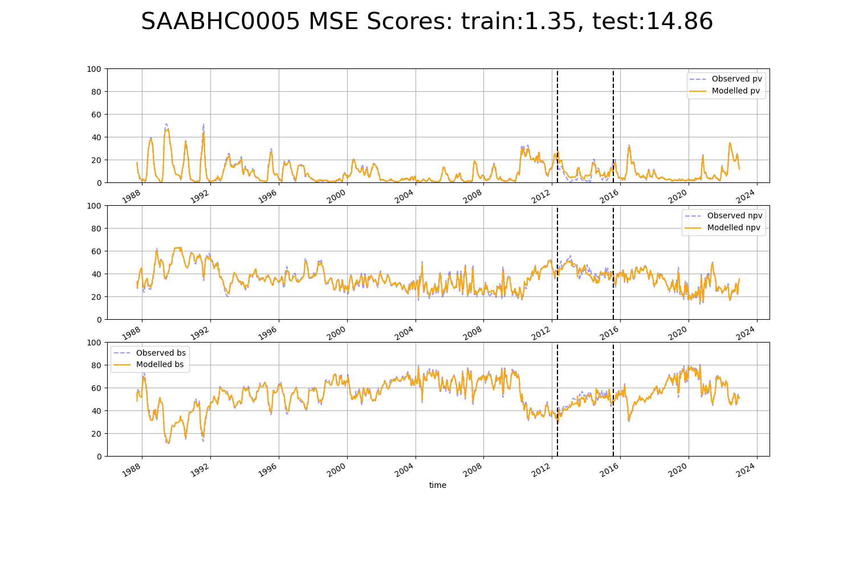

# SAABHC0006

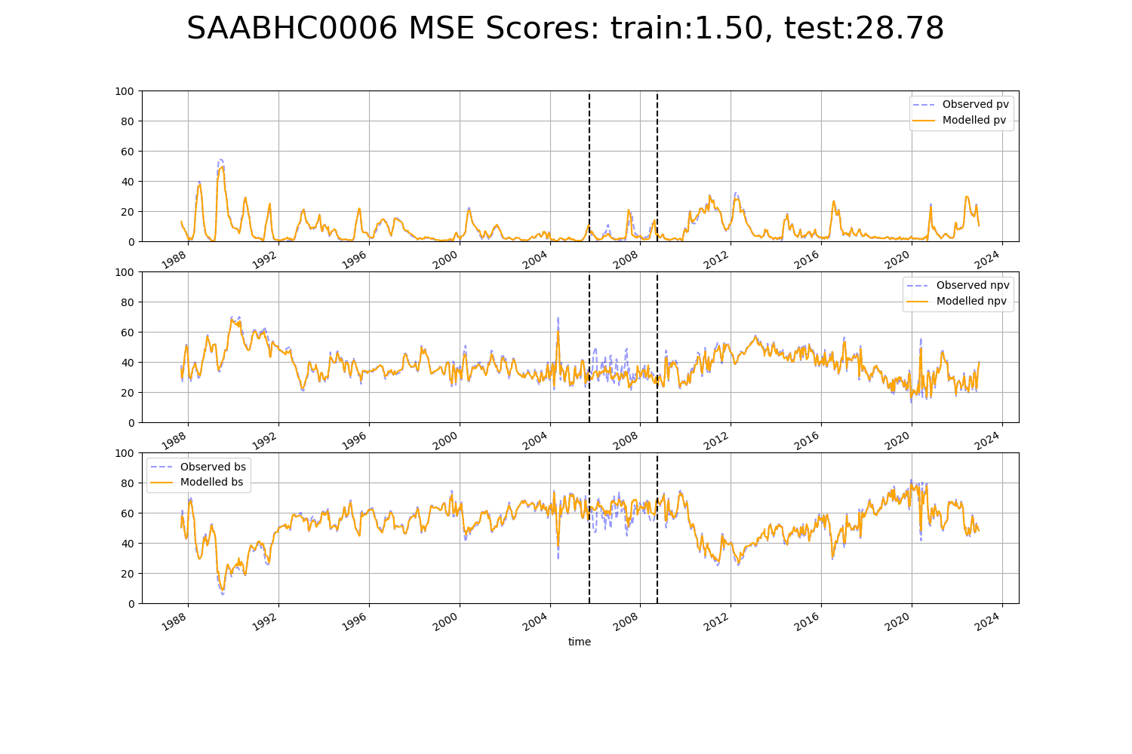

# SAAFLB0031

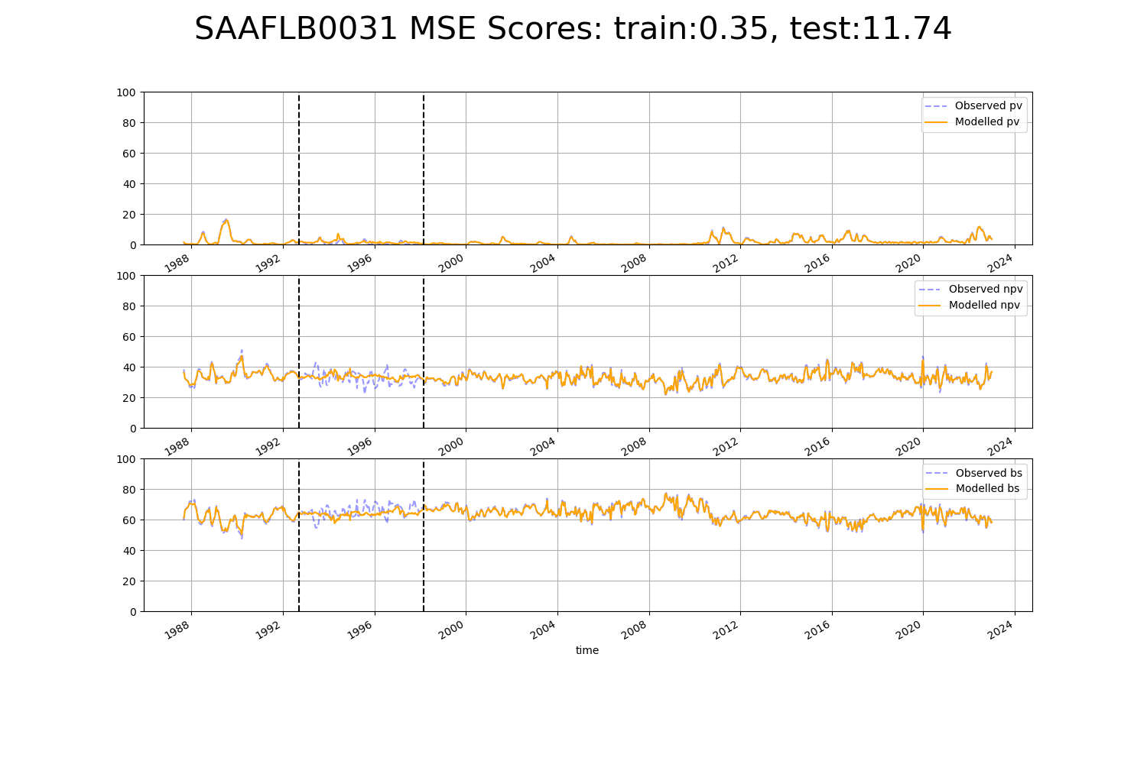

# SAAGAW0002

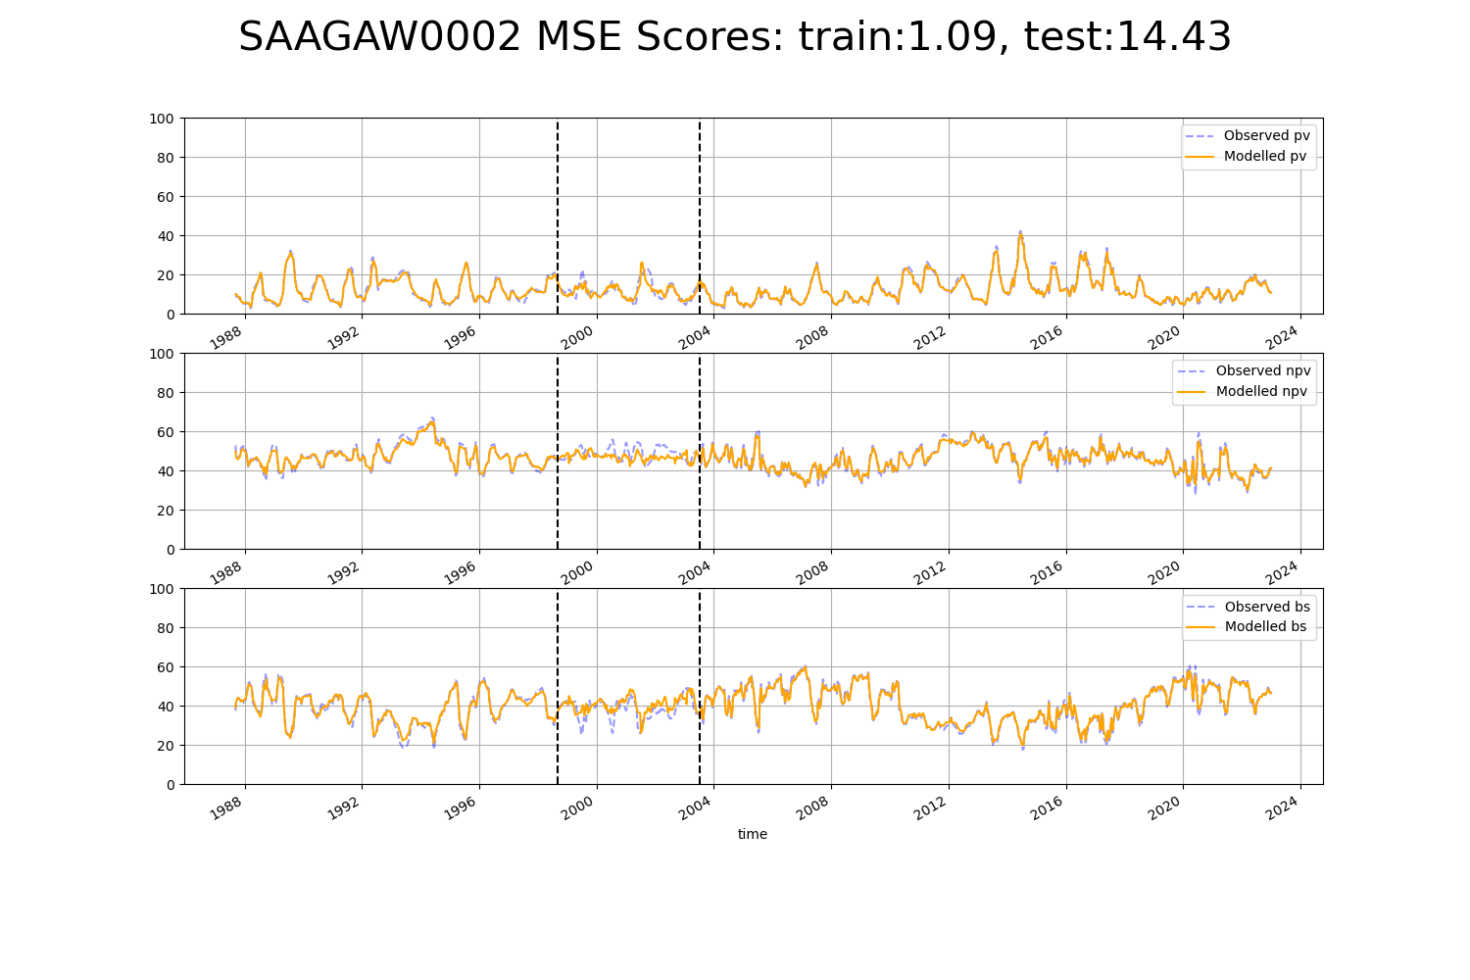

# SAAGAW0006

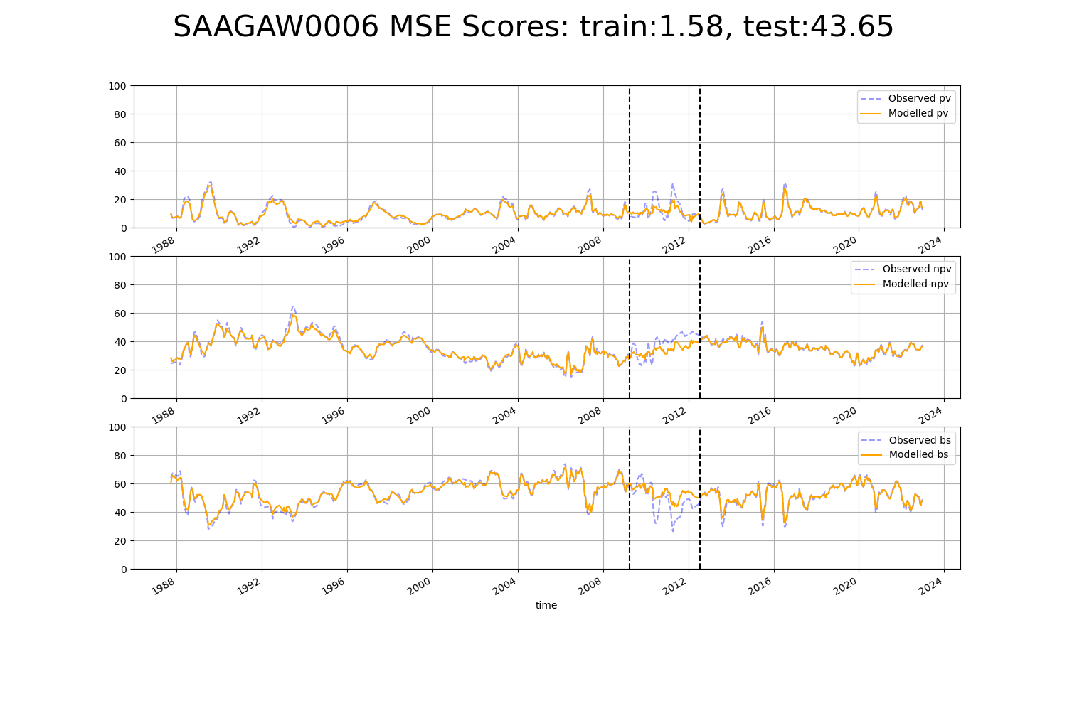

# SAAGAW0007

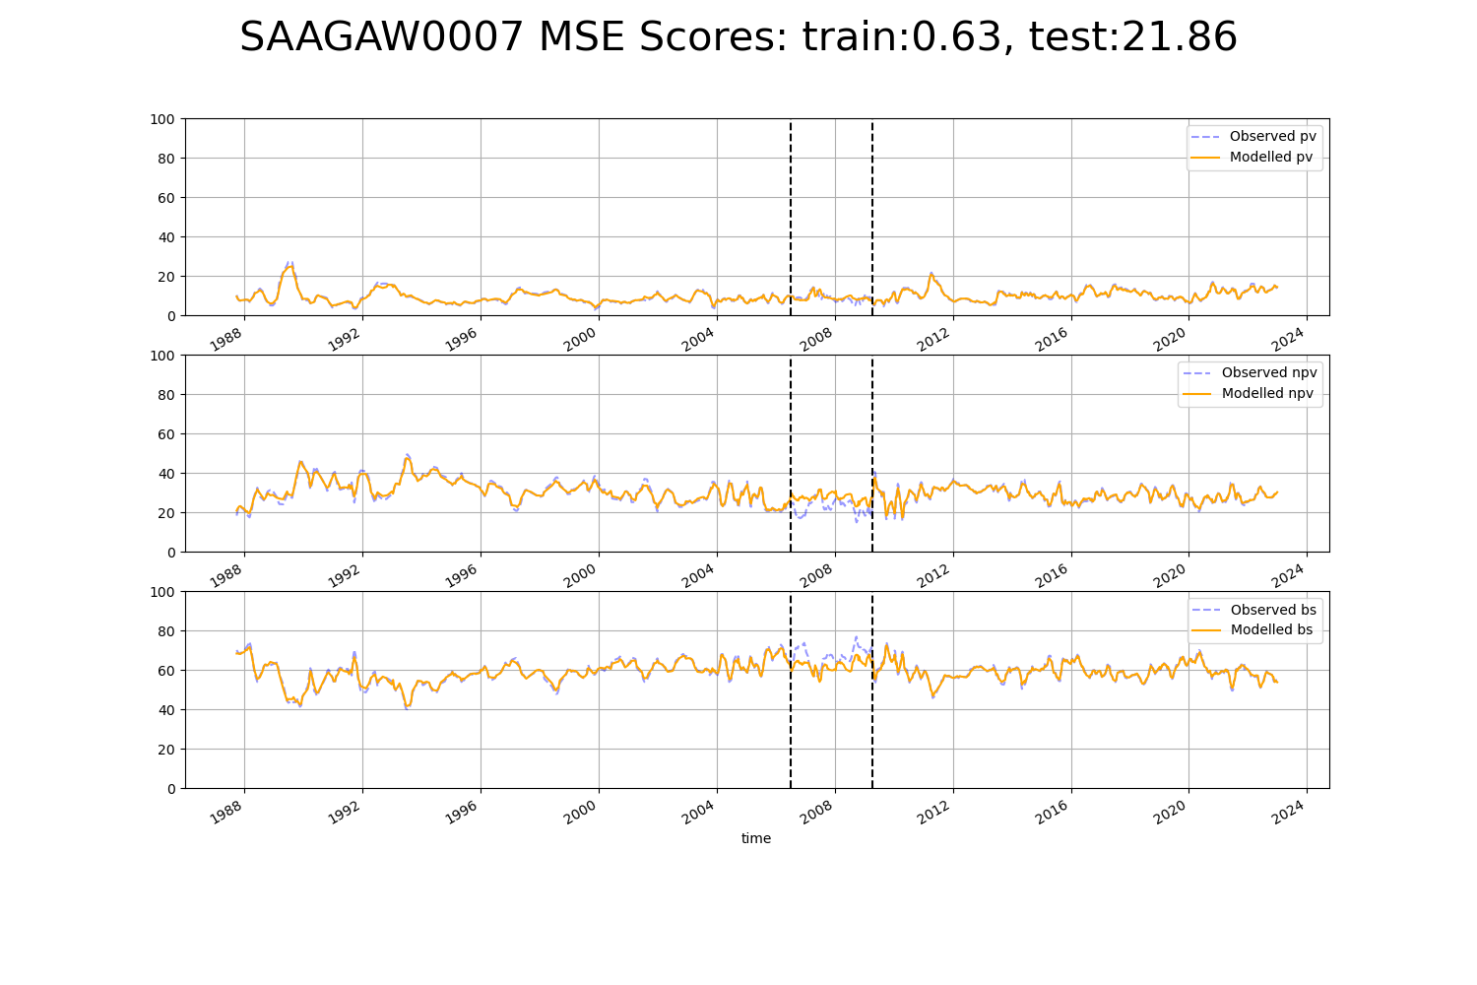

# SAAGAW0008

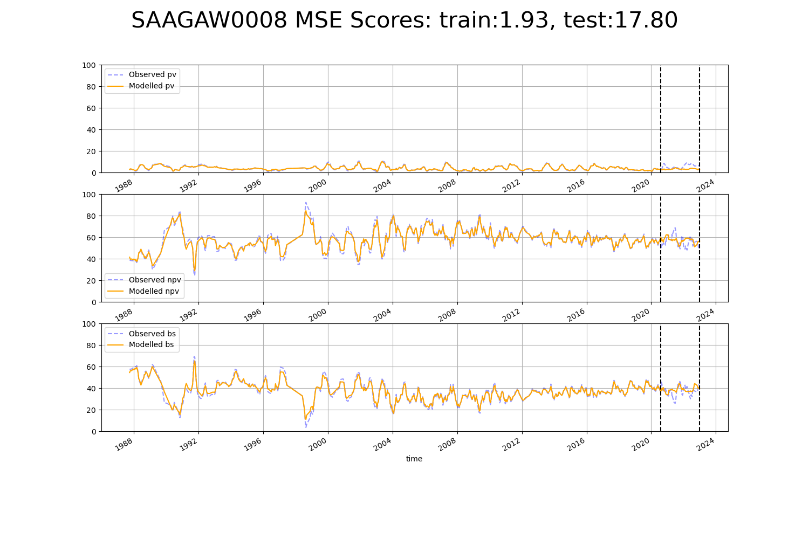

# SAAGVD0001

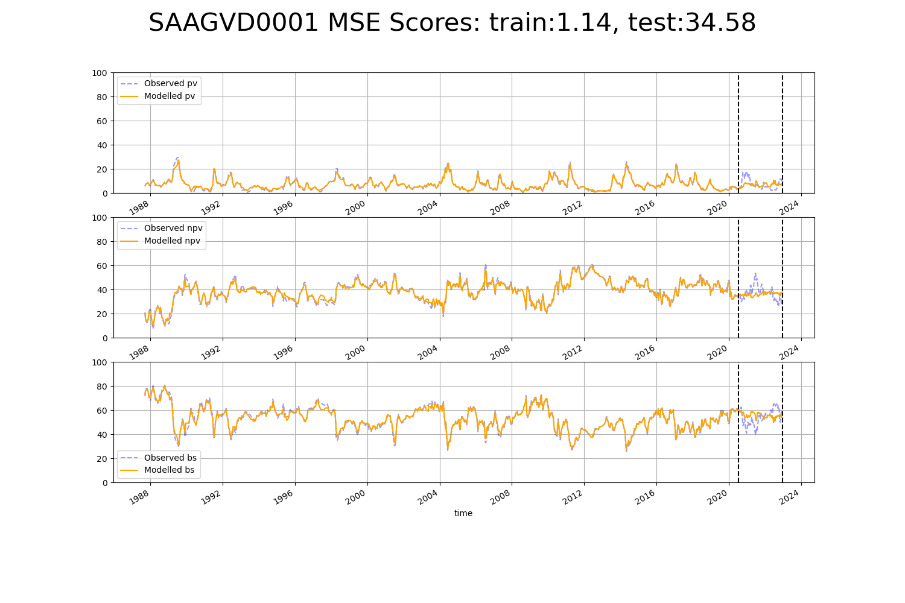

# SAAGVD0004

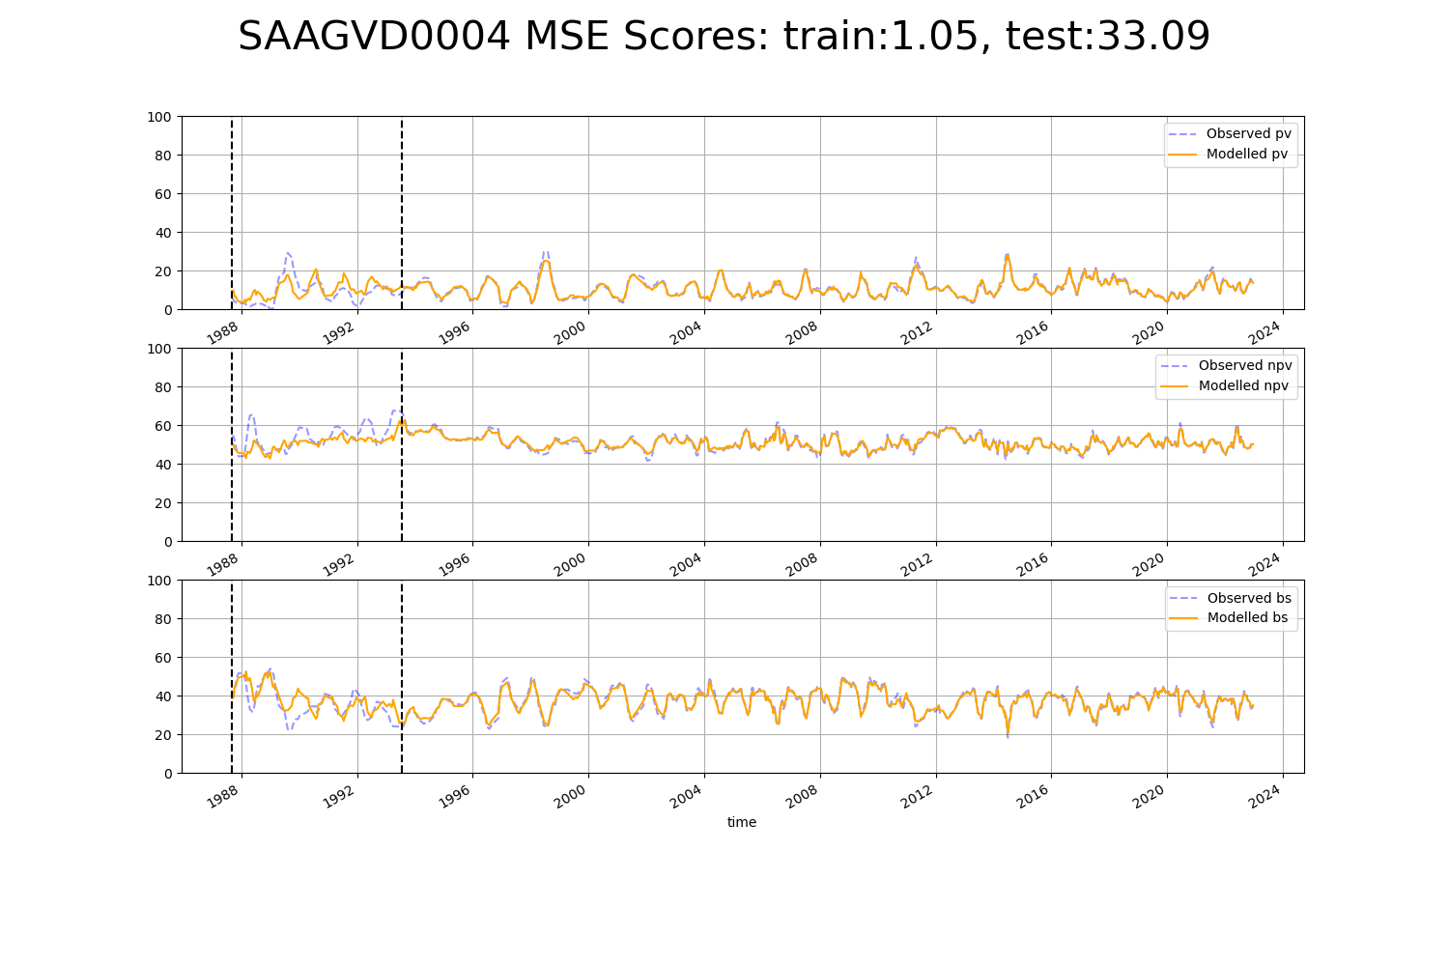

# SAANUL0001

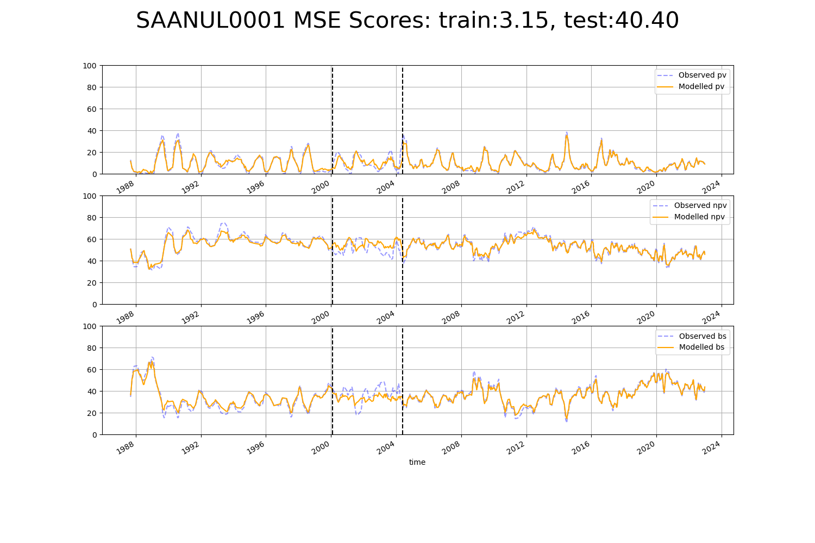

# SAANUL0002

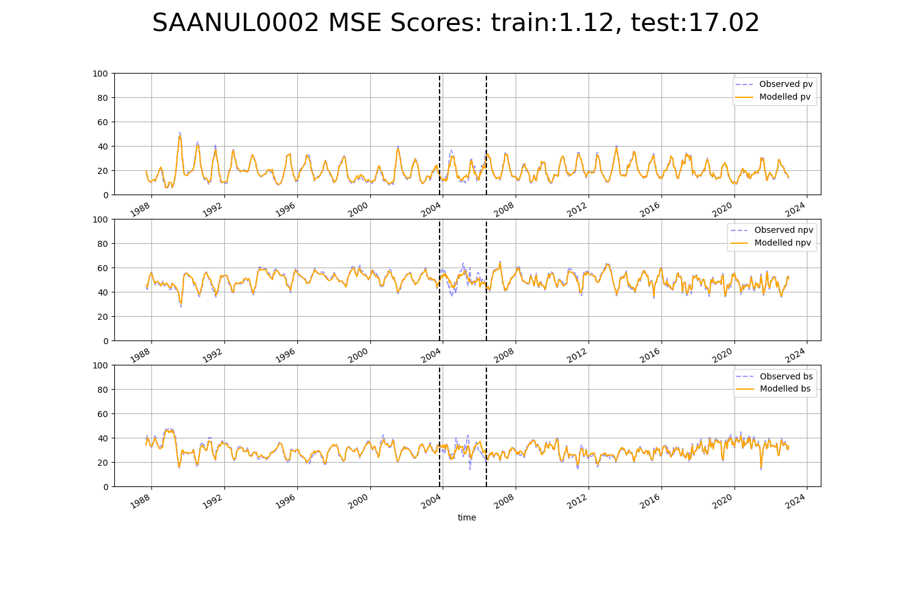

# SAANUL0004

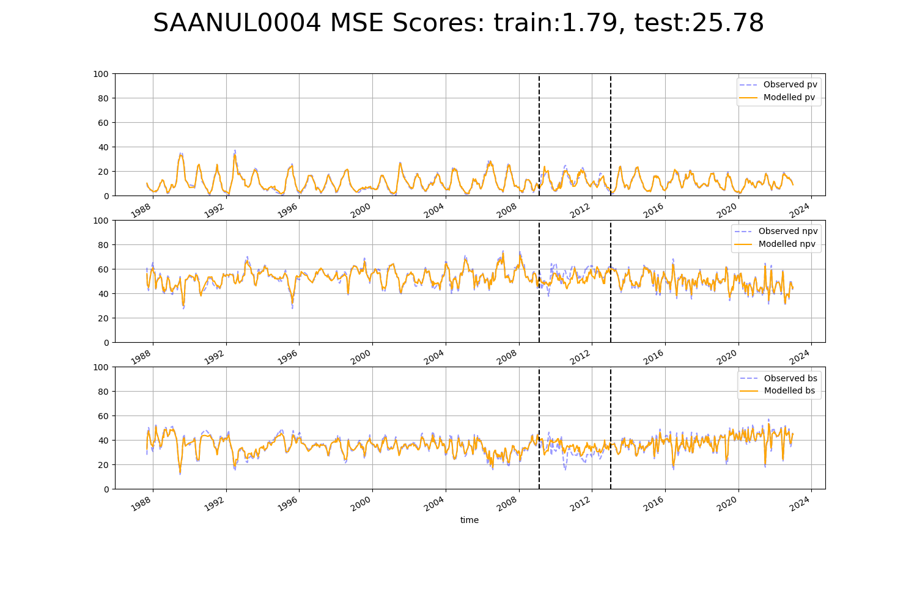

# SAARIV0008

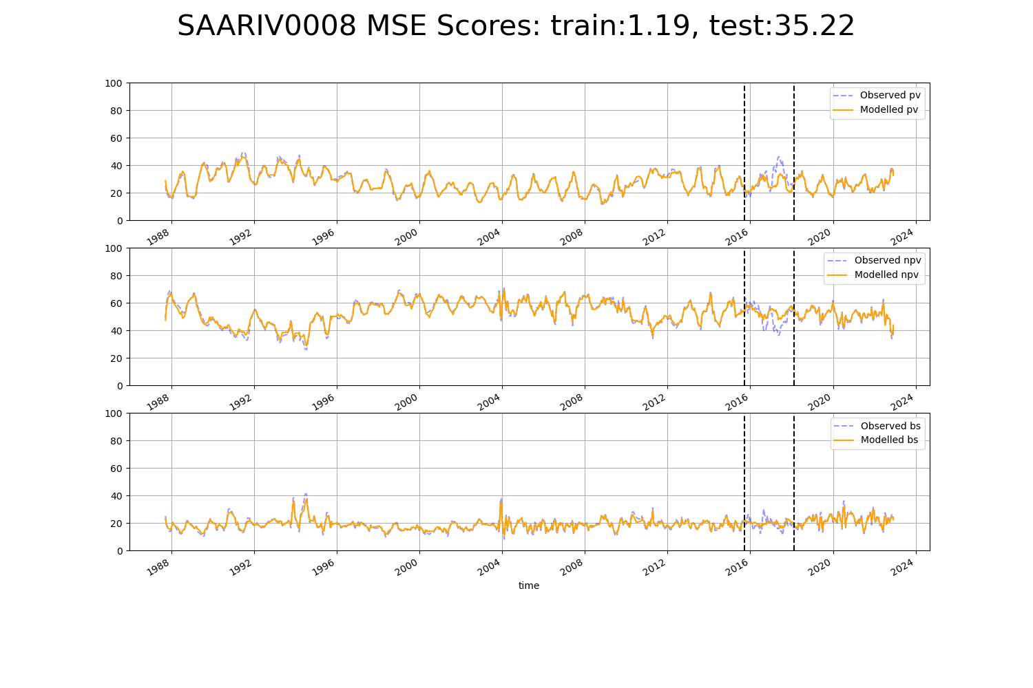

# SAARIV0009

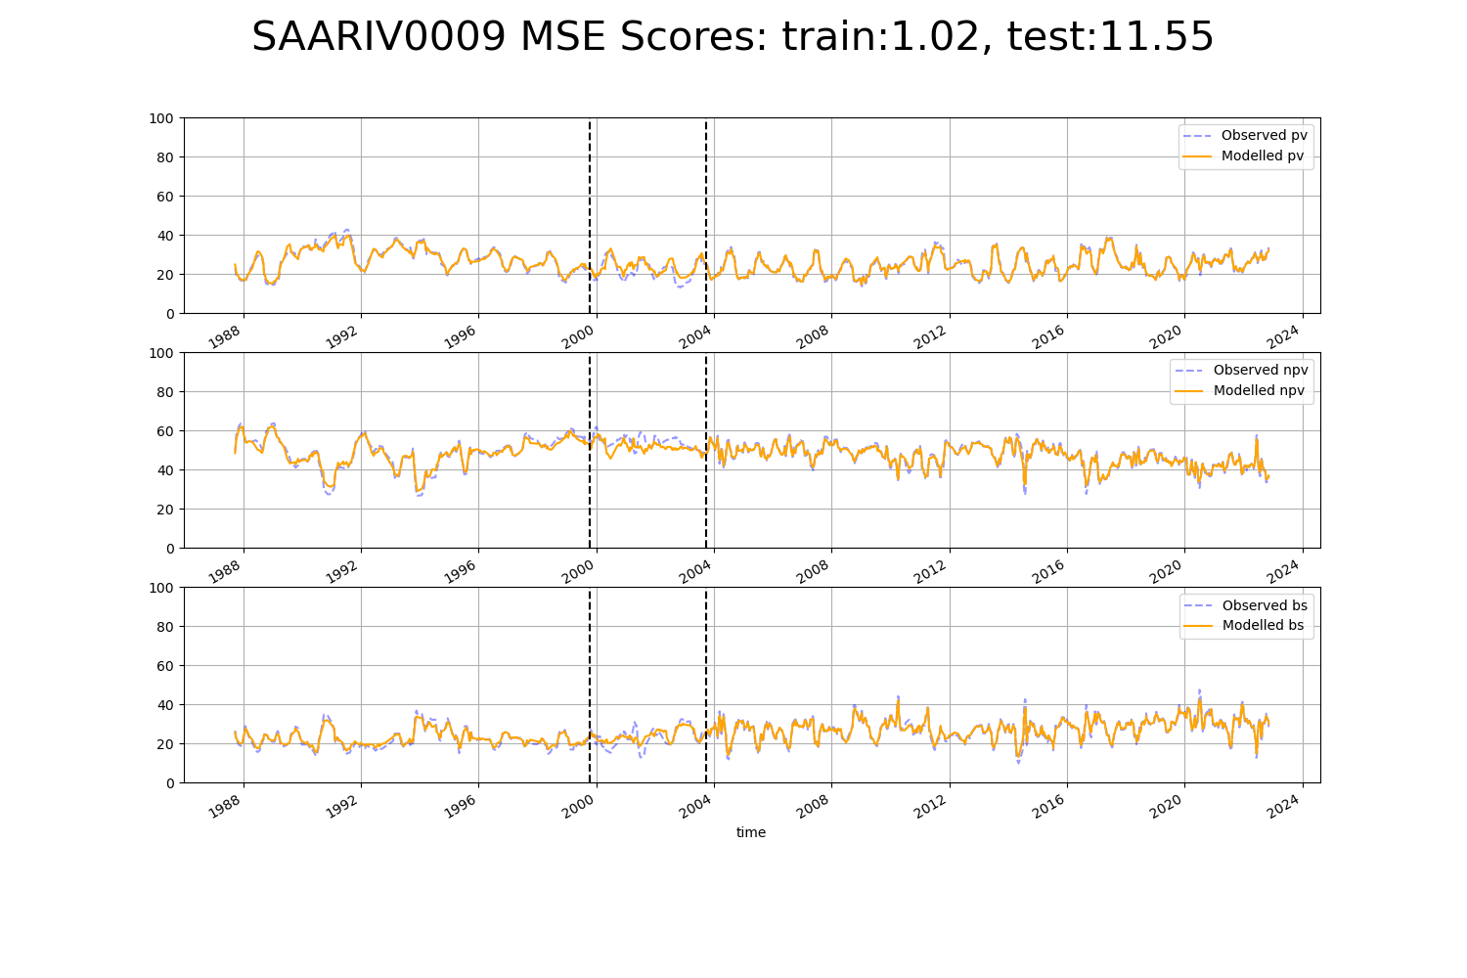

# SAASTP0001

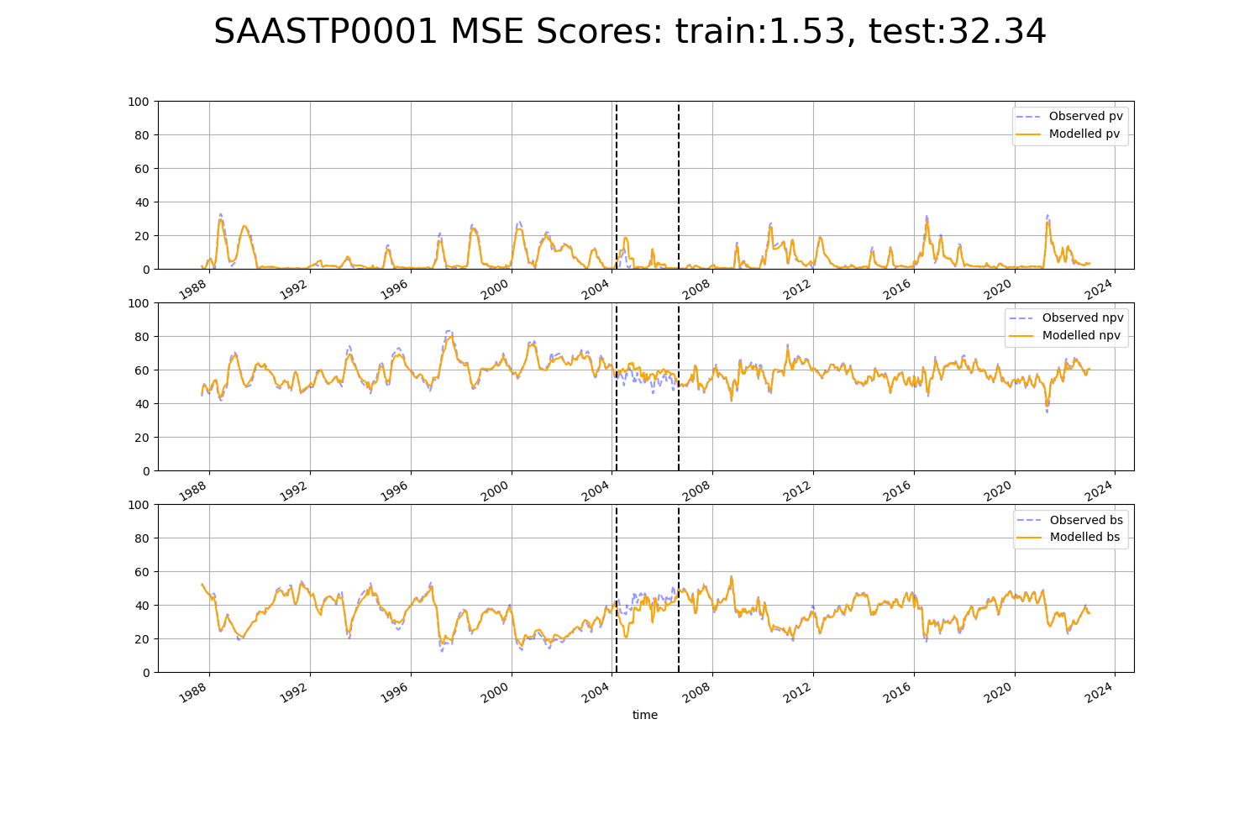

# SAASTP0003

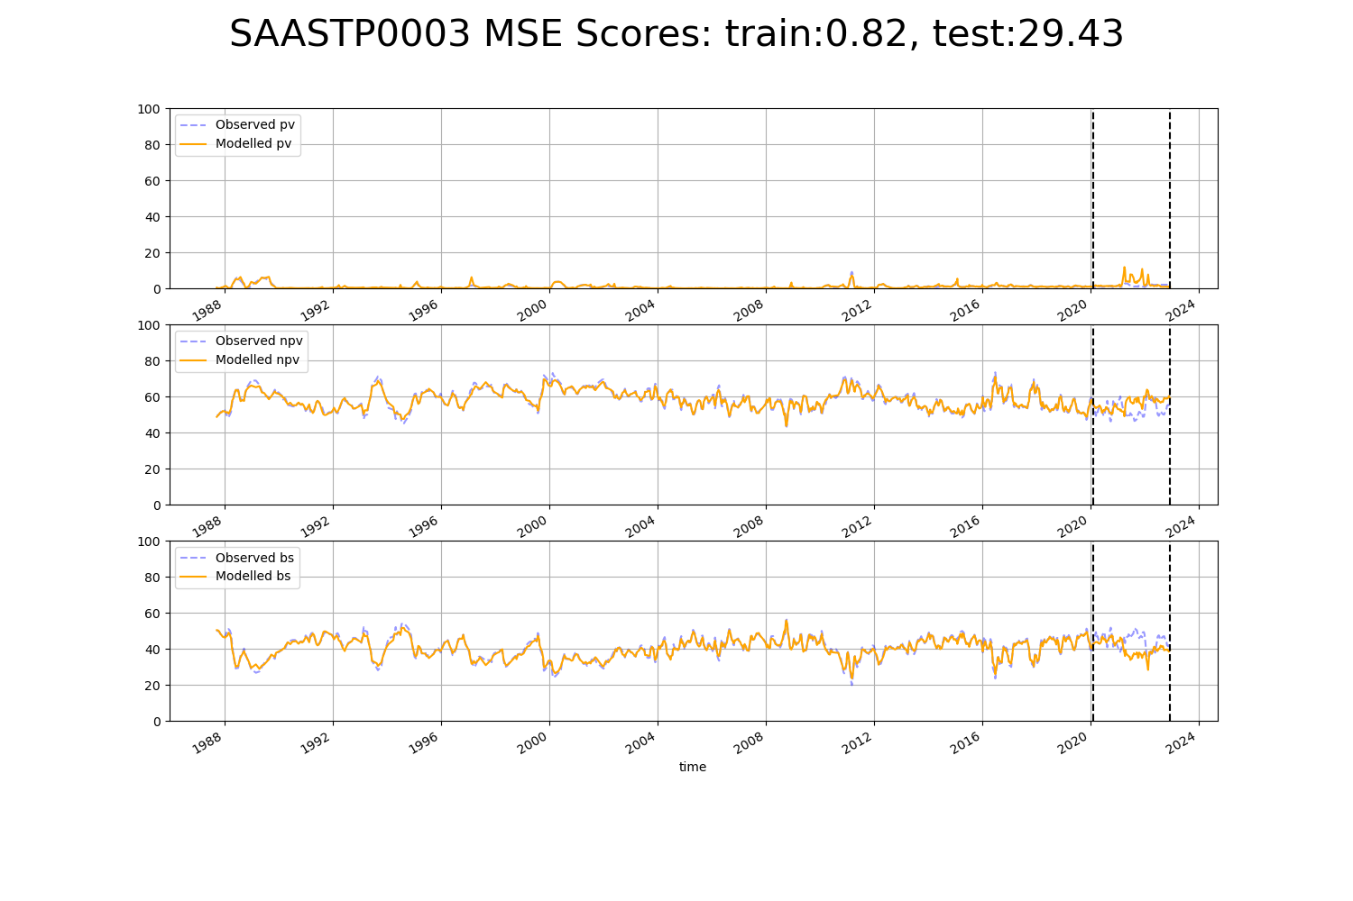

# SAASTP0007

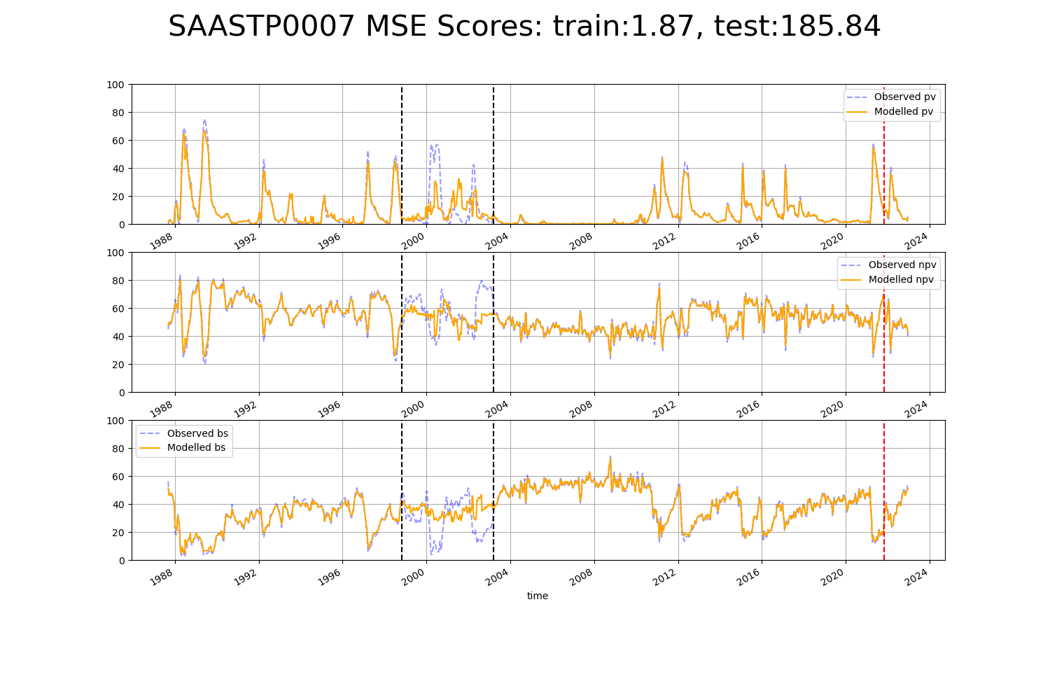

# SAASTP0008

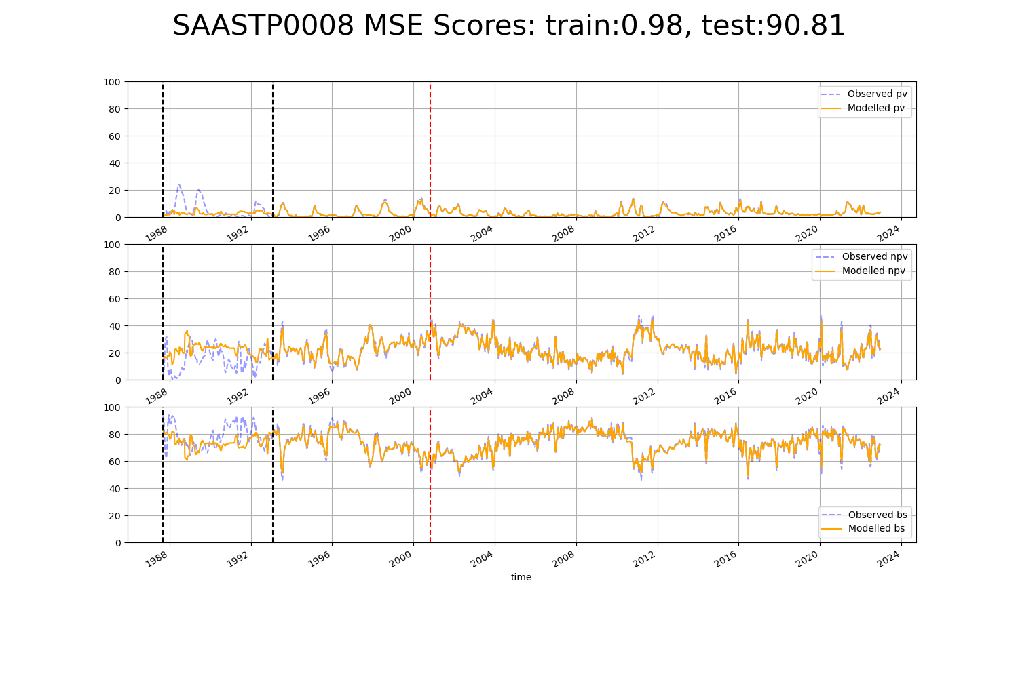

# SAASTP0010

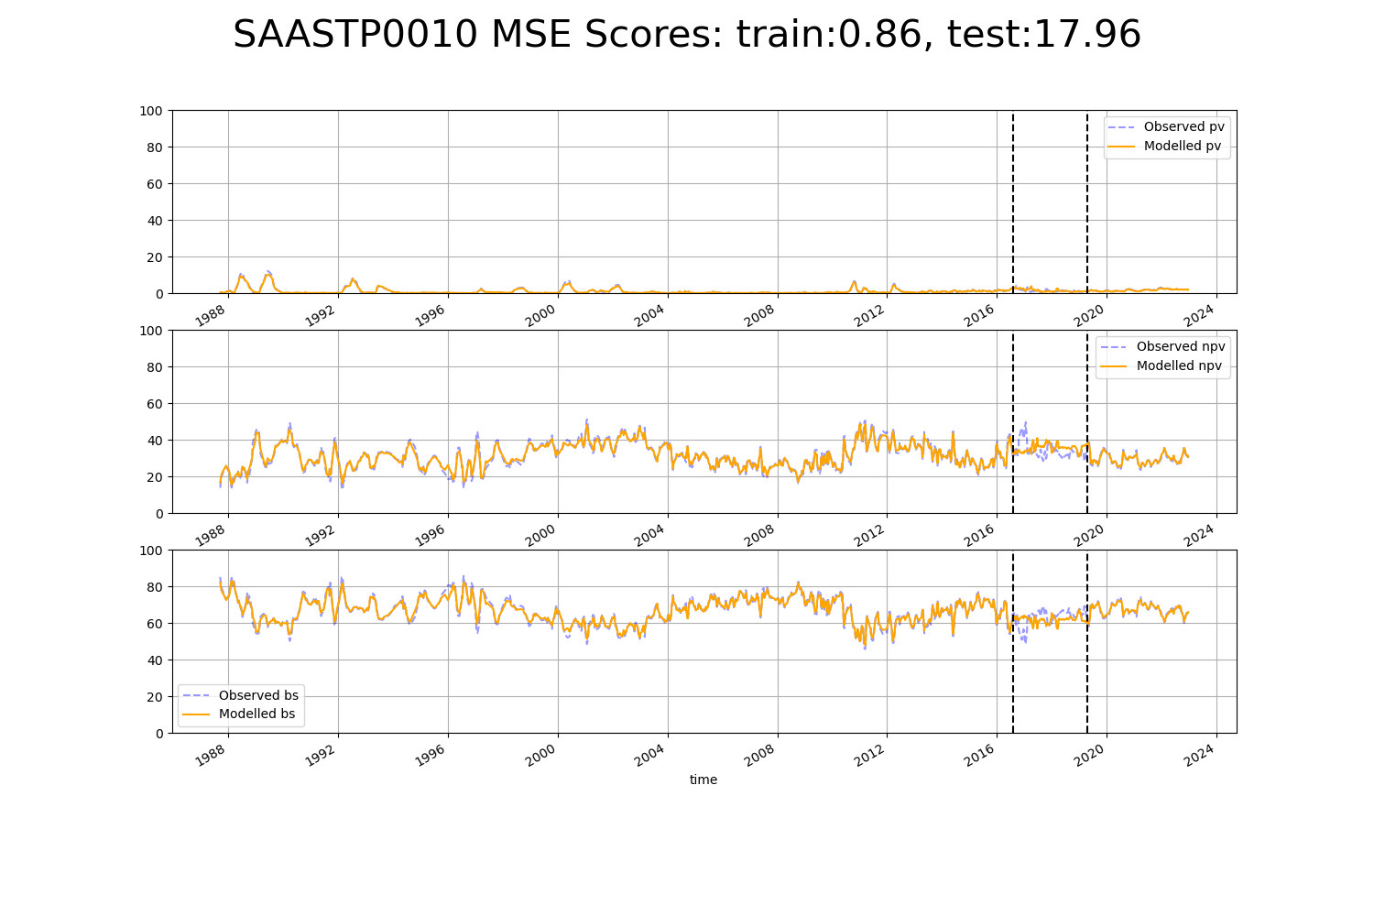

# SAASTP0014

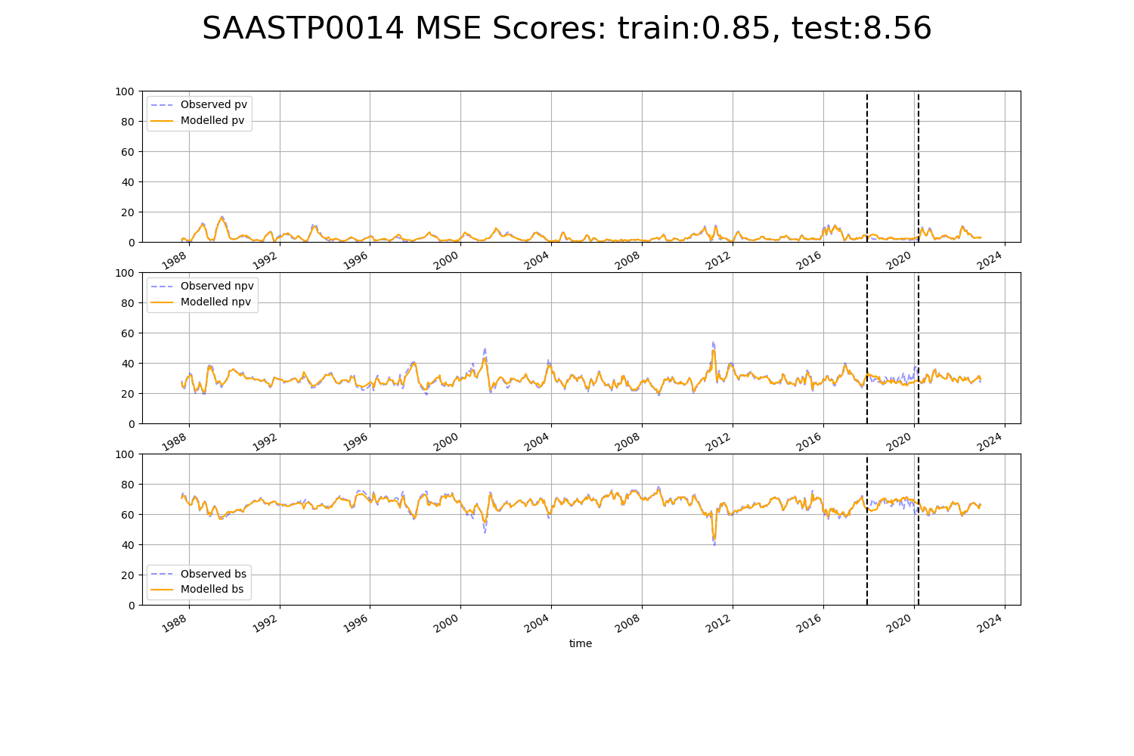

# SAASTP0016

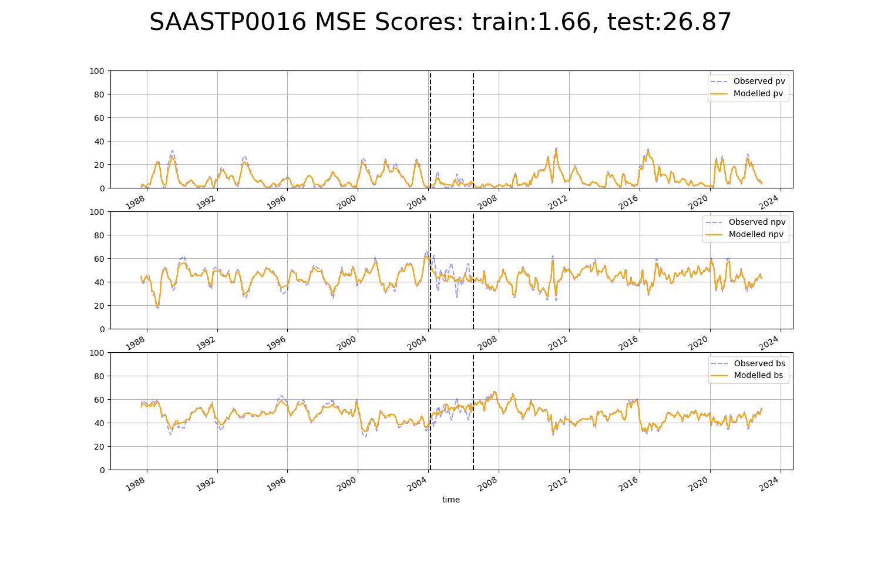

# SAASTP0017

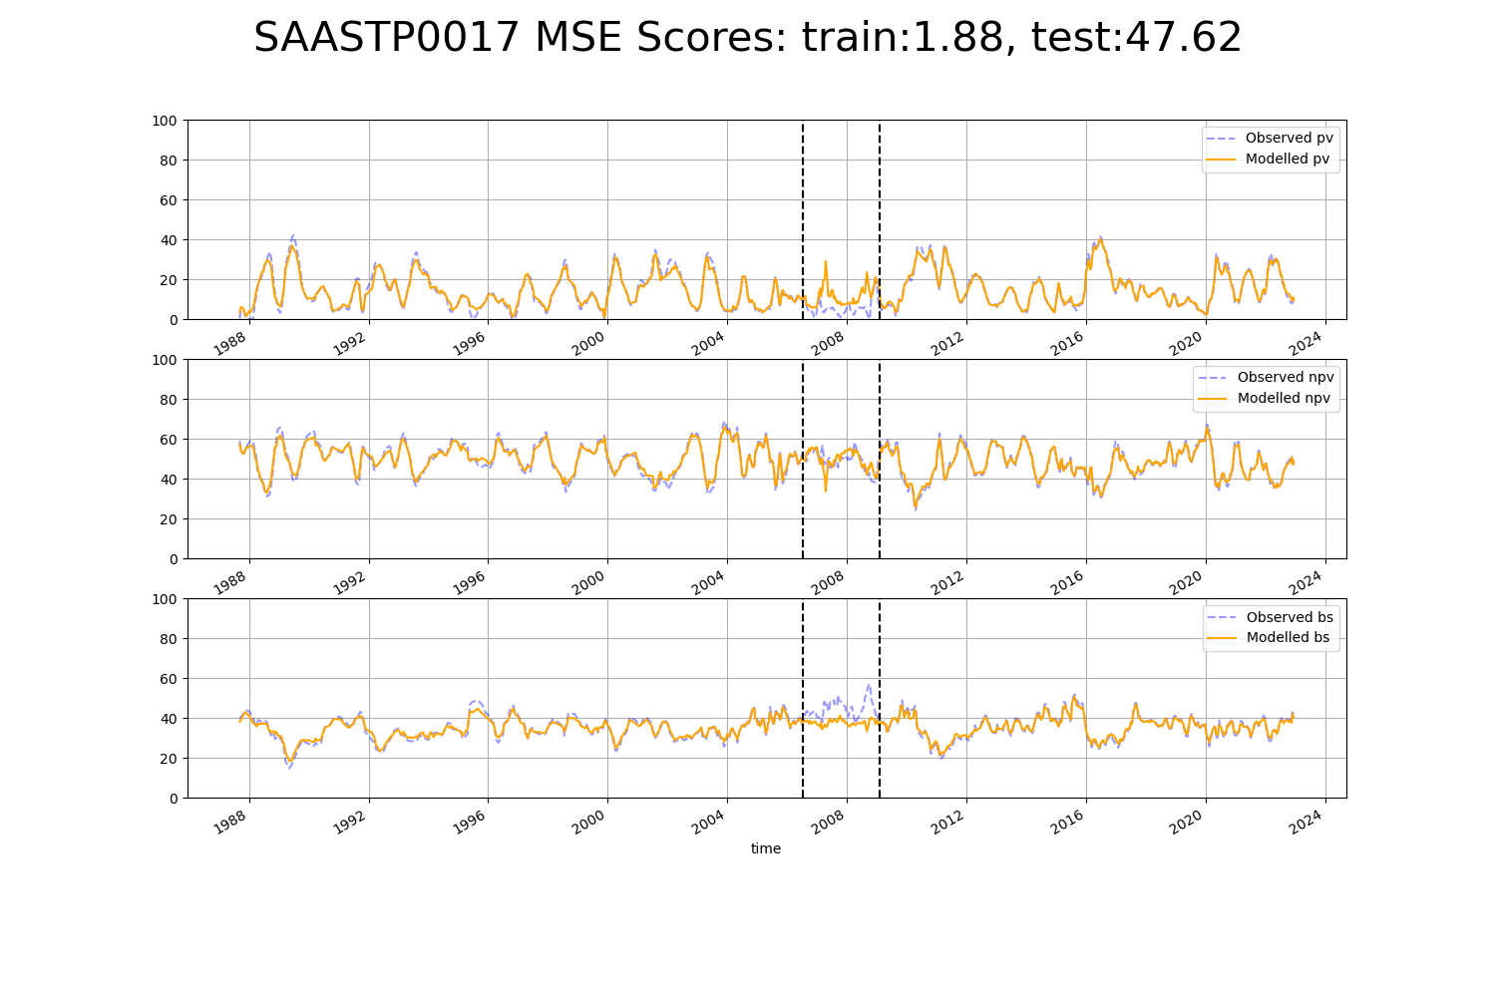

# SAASTP0019

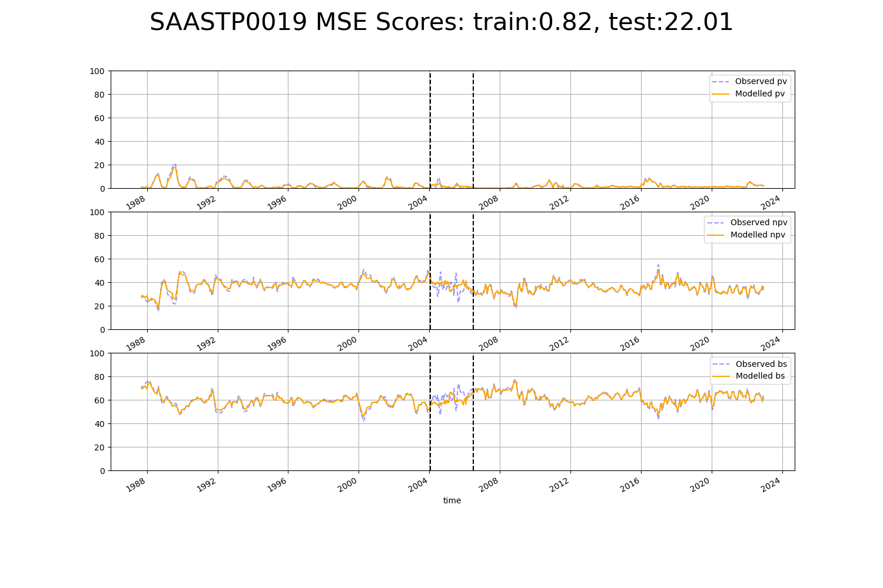

# SAASTP0021

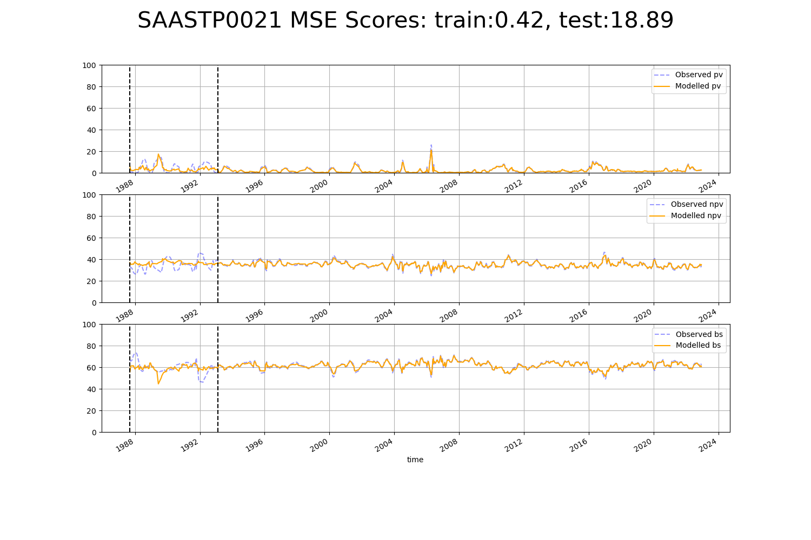

# SAASTP0022

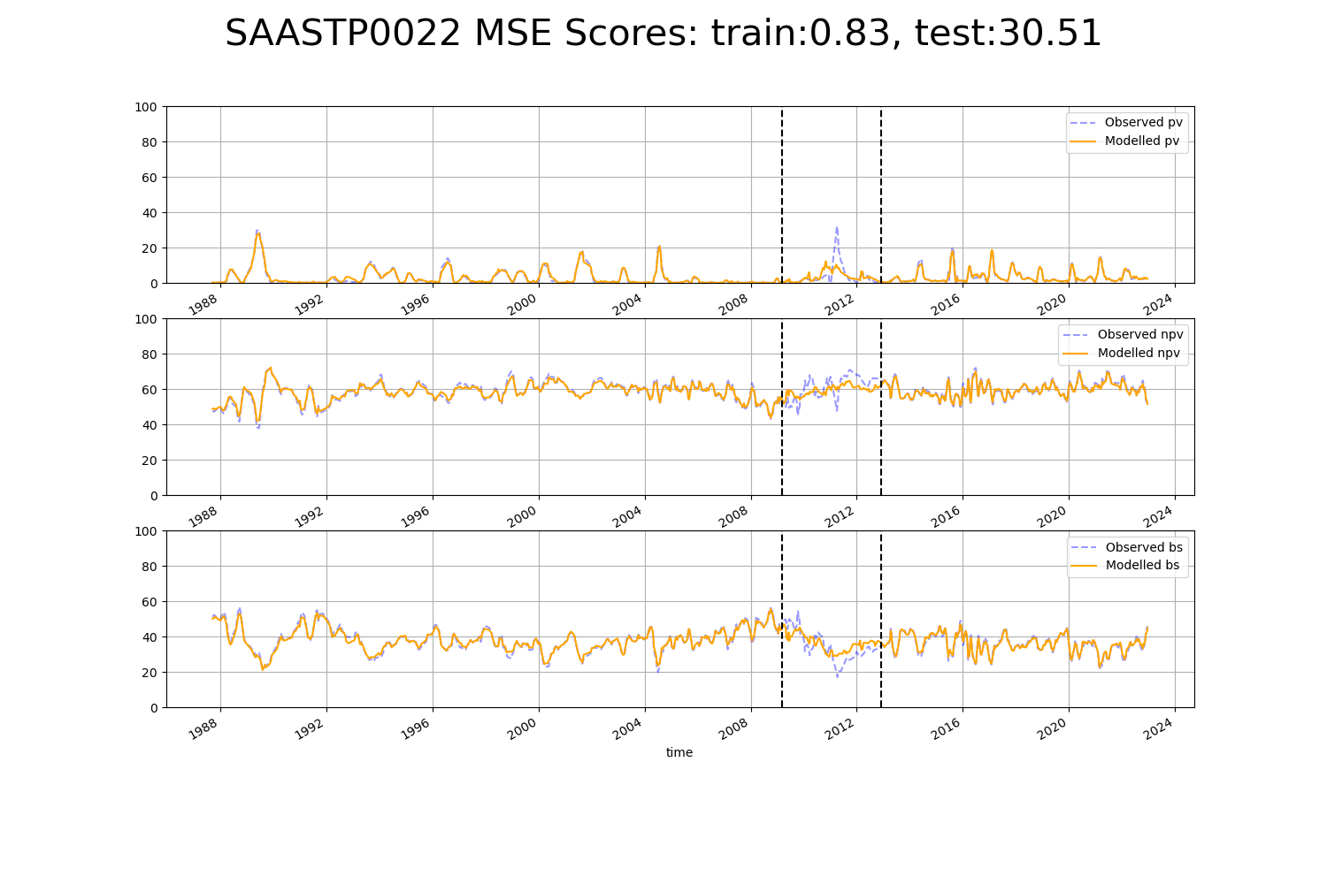

# SAASTP0023

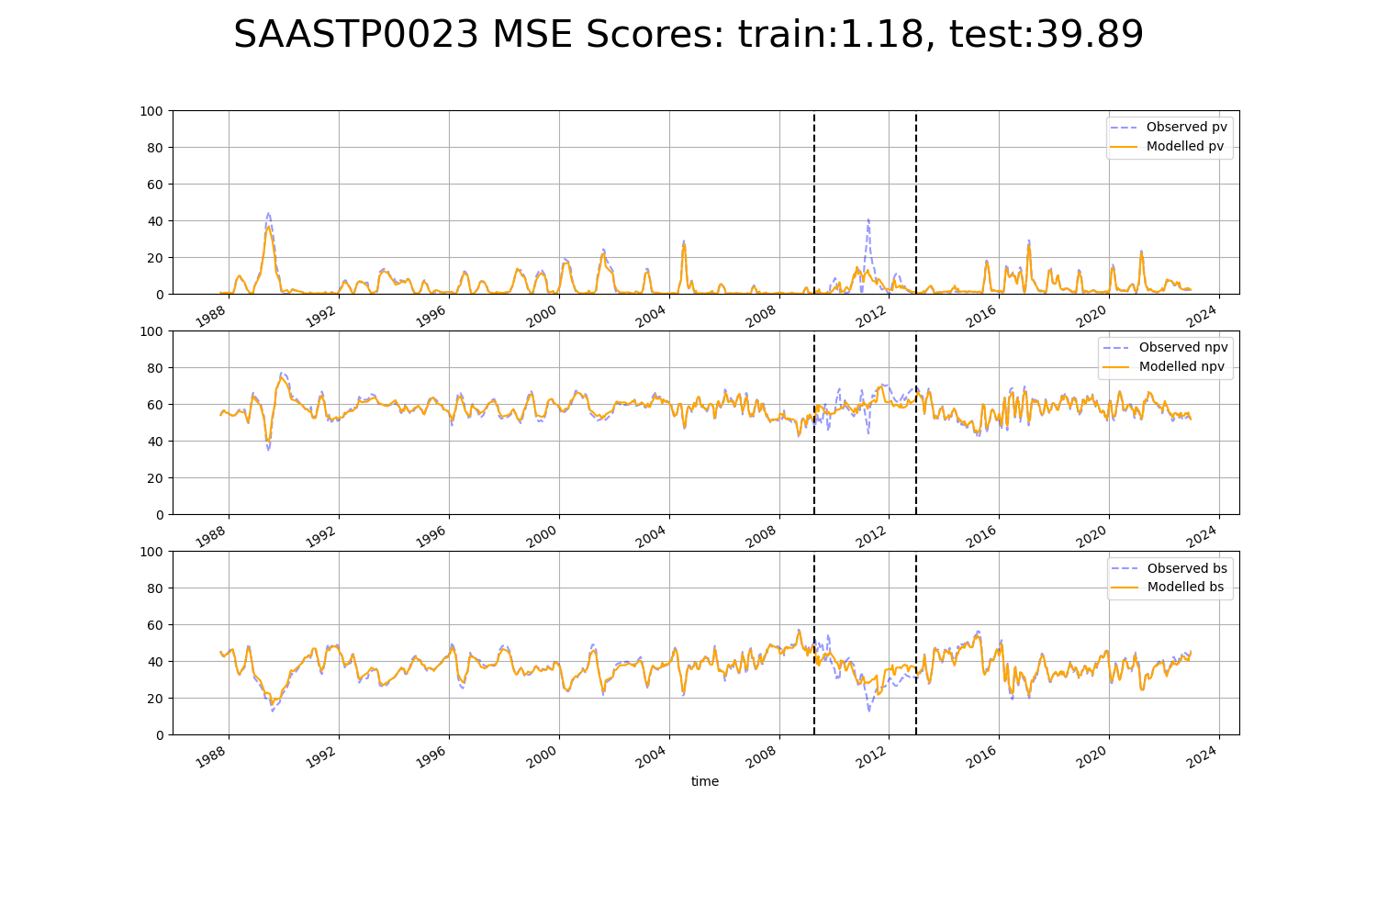

# SAASTP0024

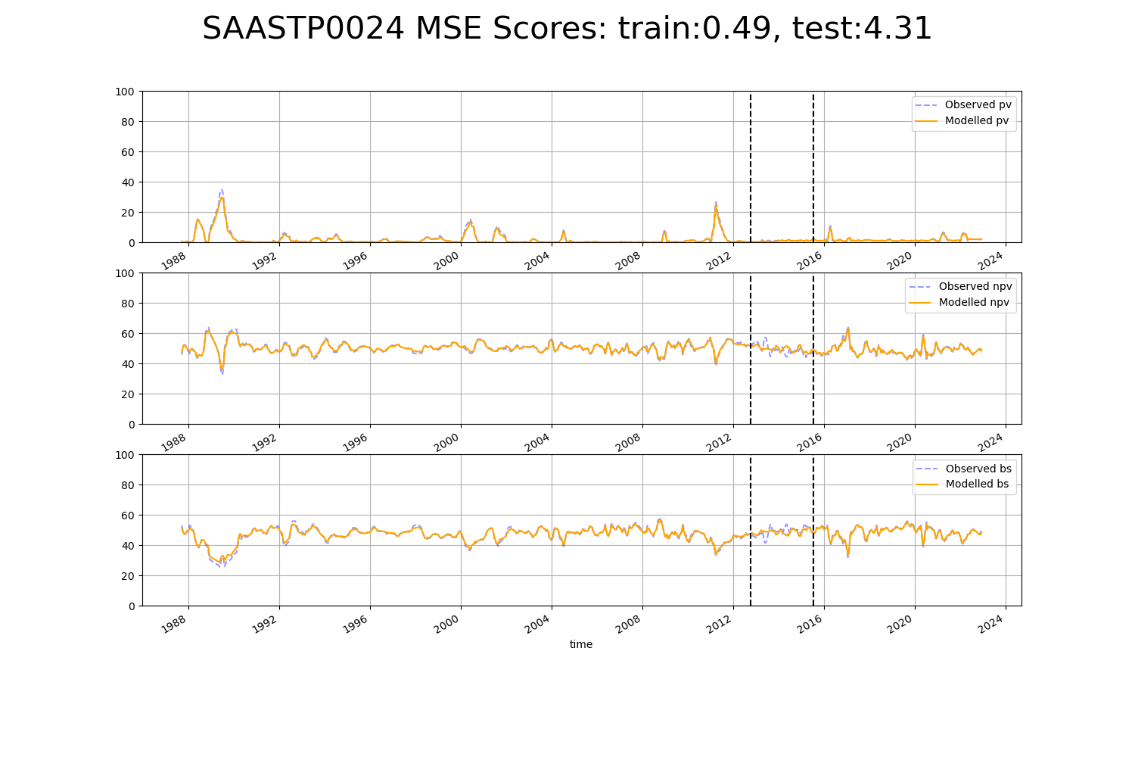

# SAASTP0025

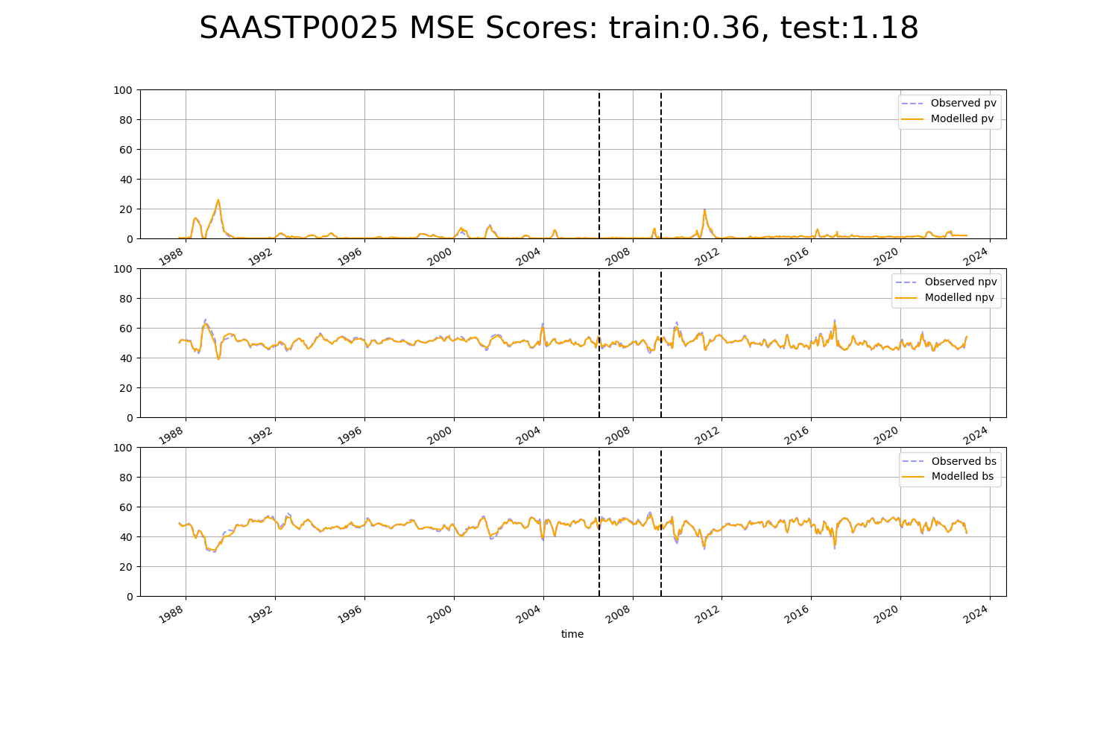

# SAASTP0026

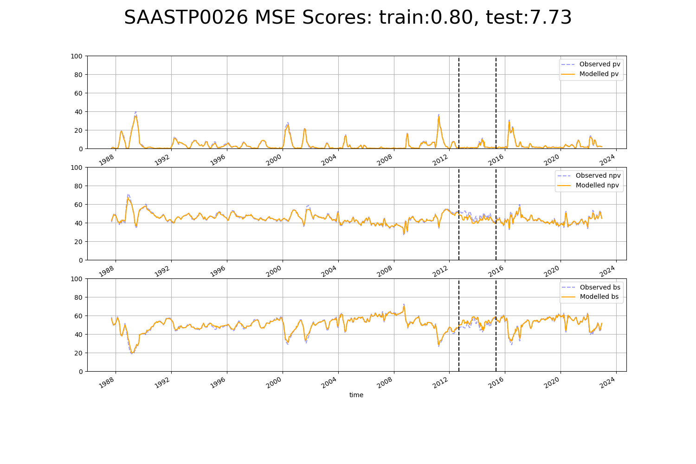

# SAASTP0027

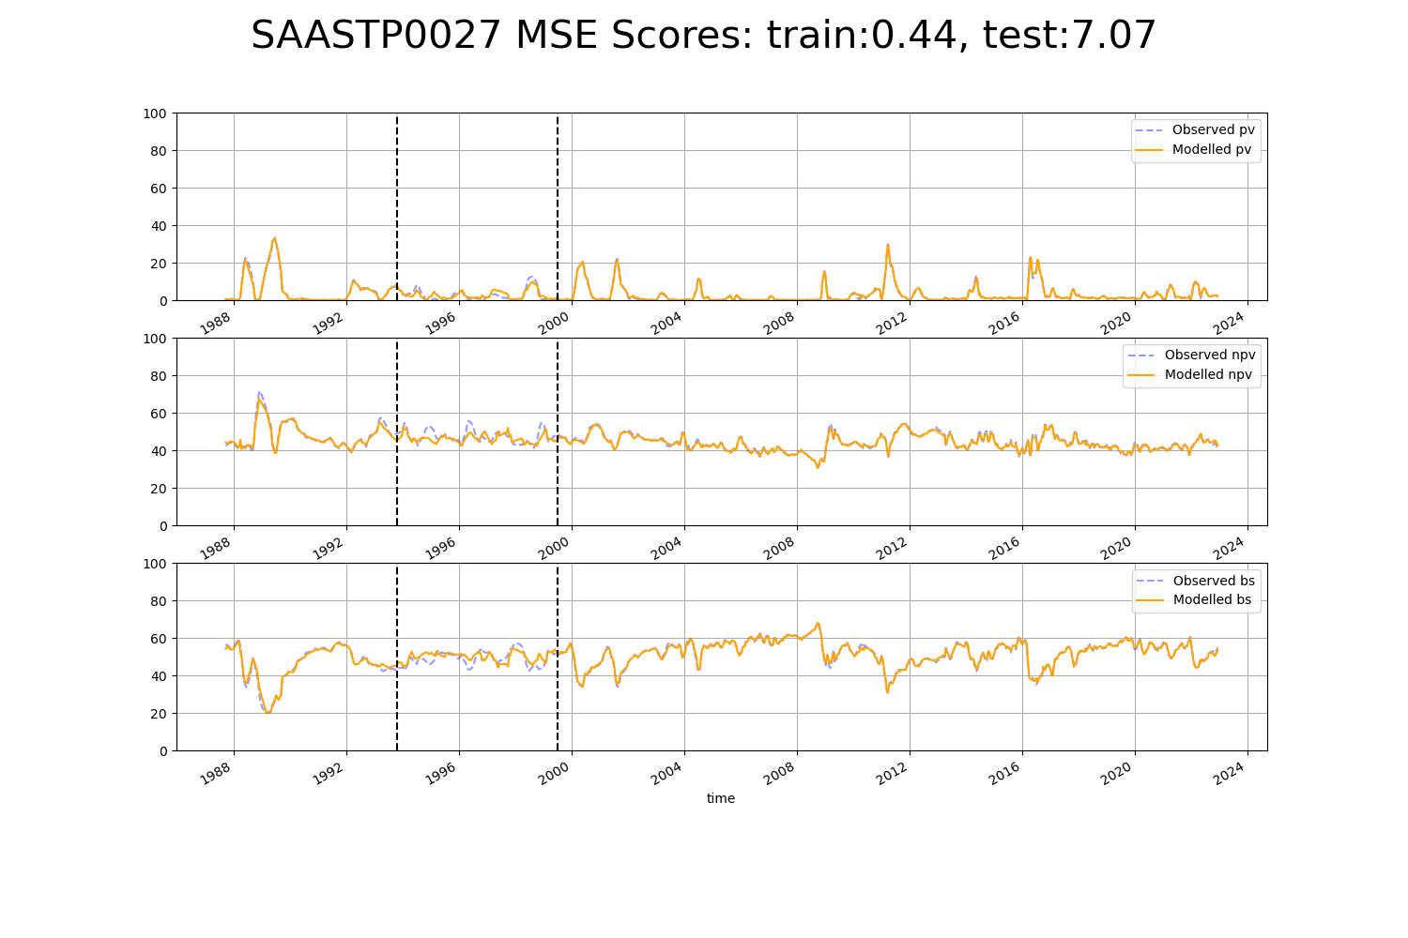

# SAASTP0028

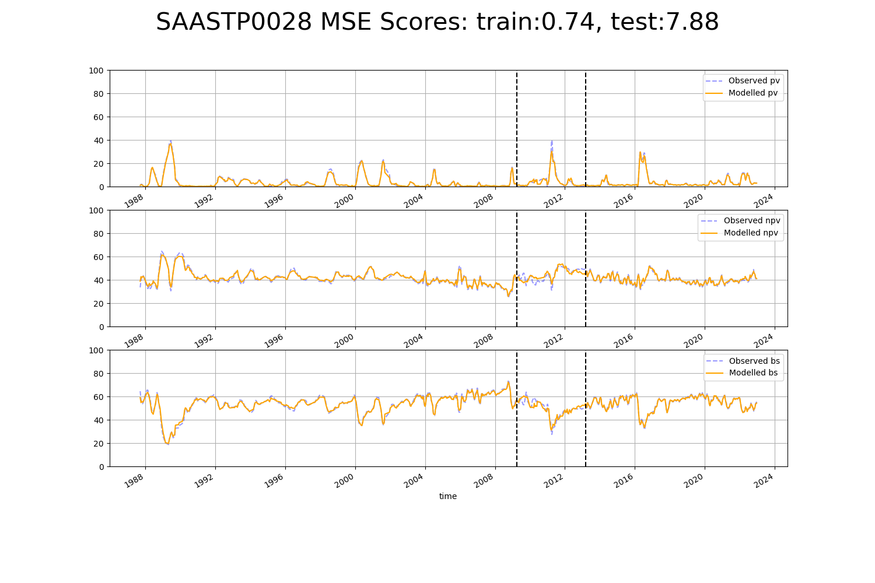

# SAASTP0029

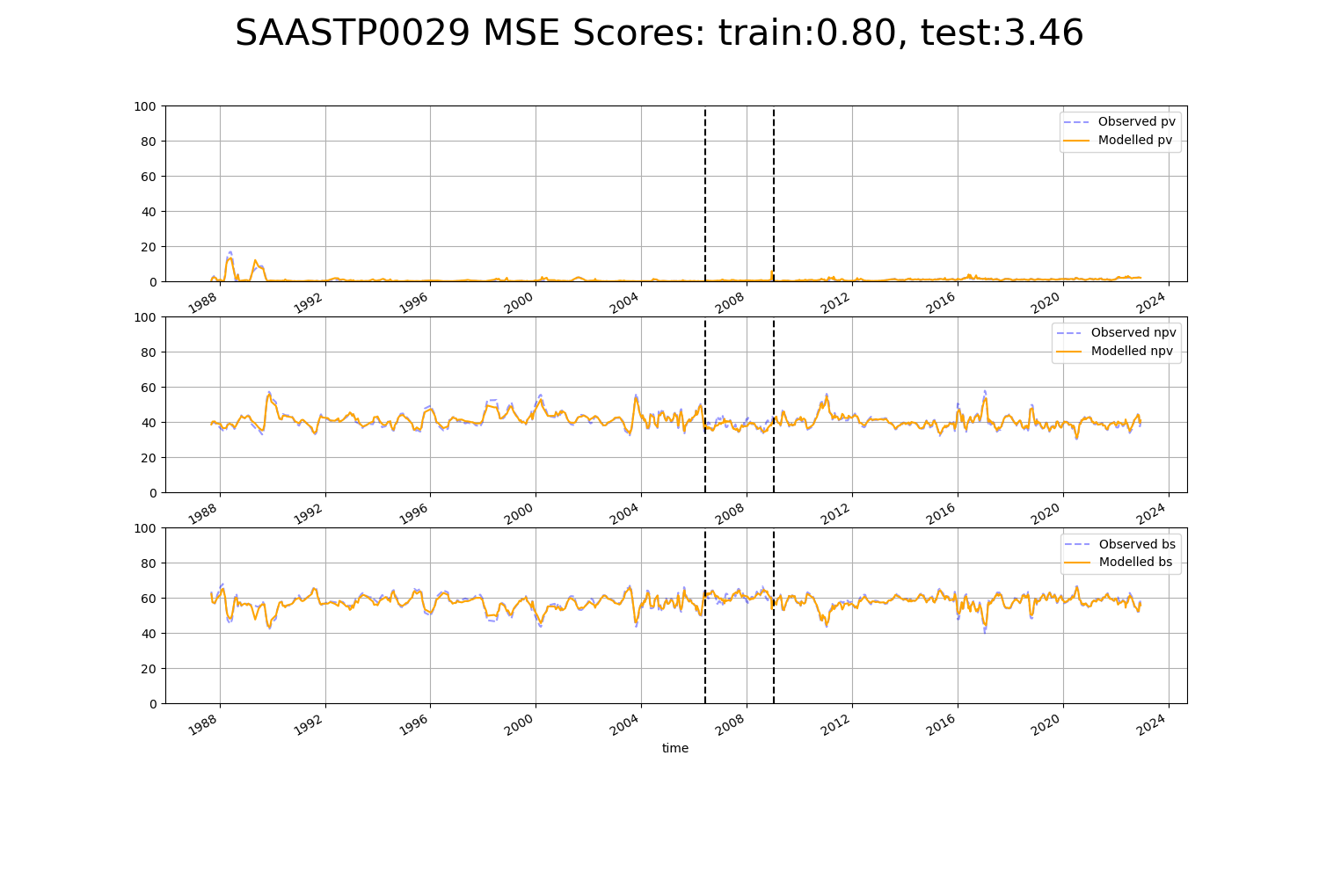

# SAASTP0033

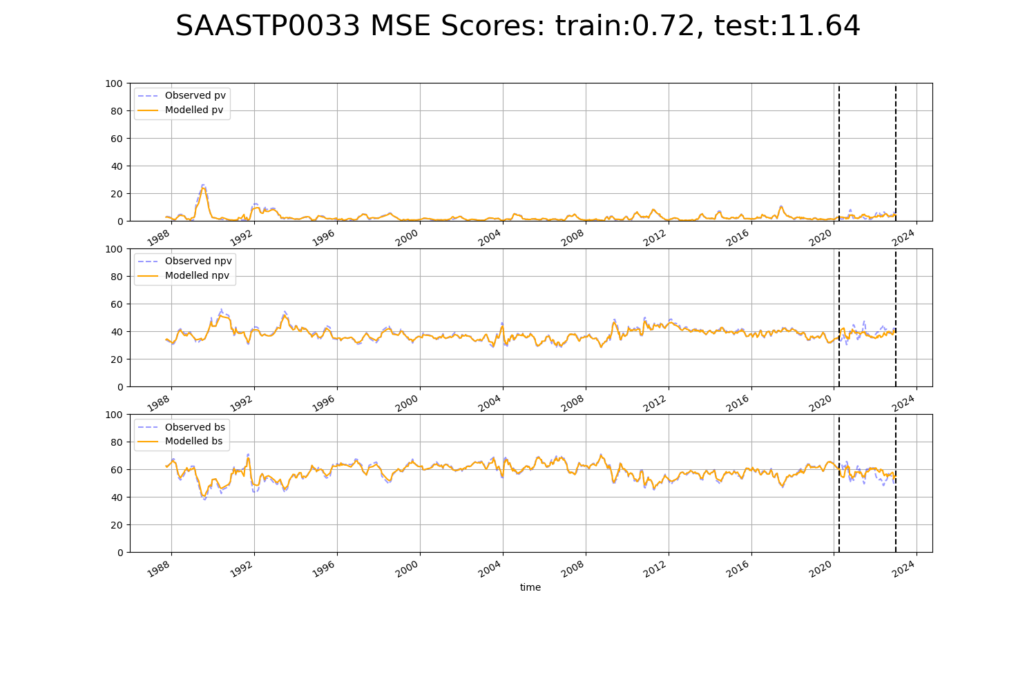

# SAASTP0034

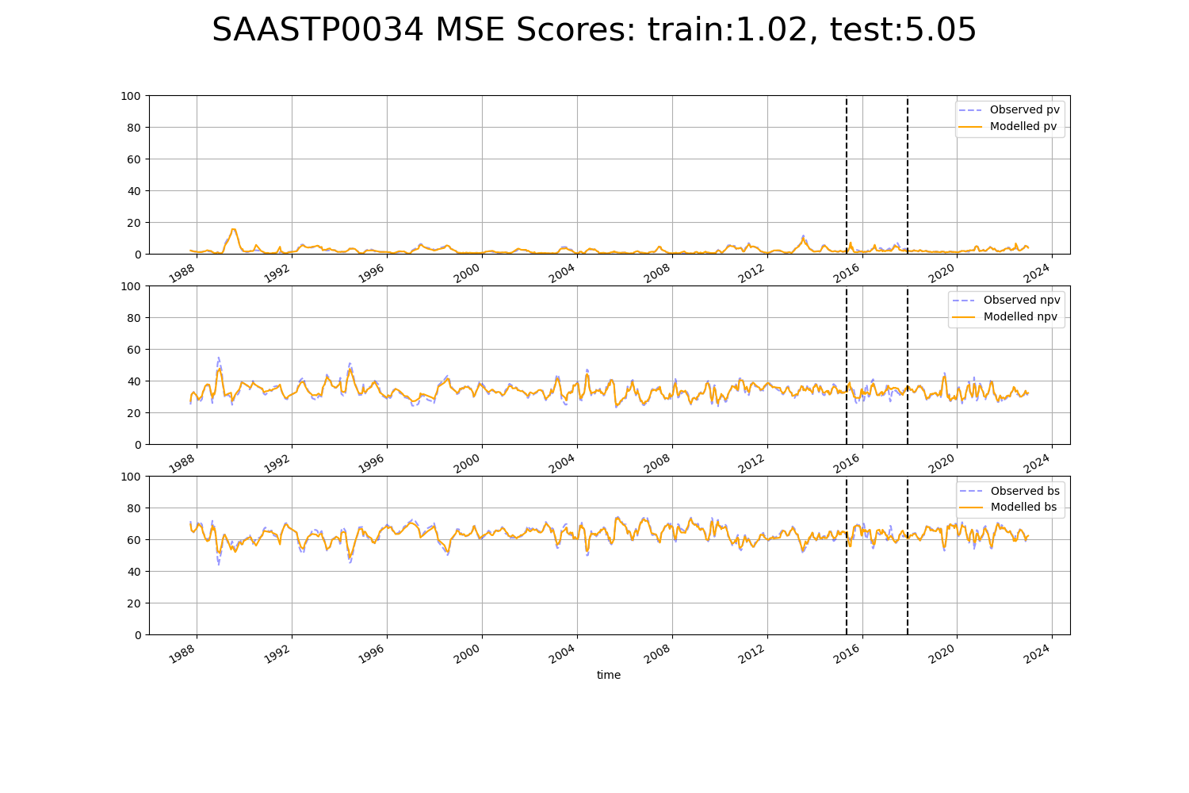

# SASMDD0004

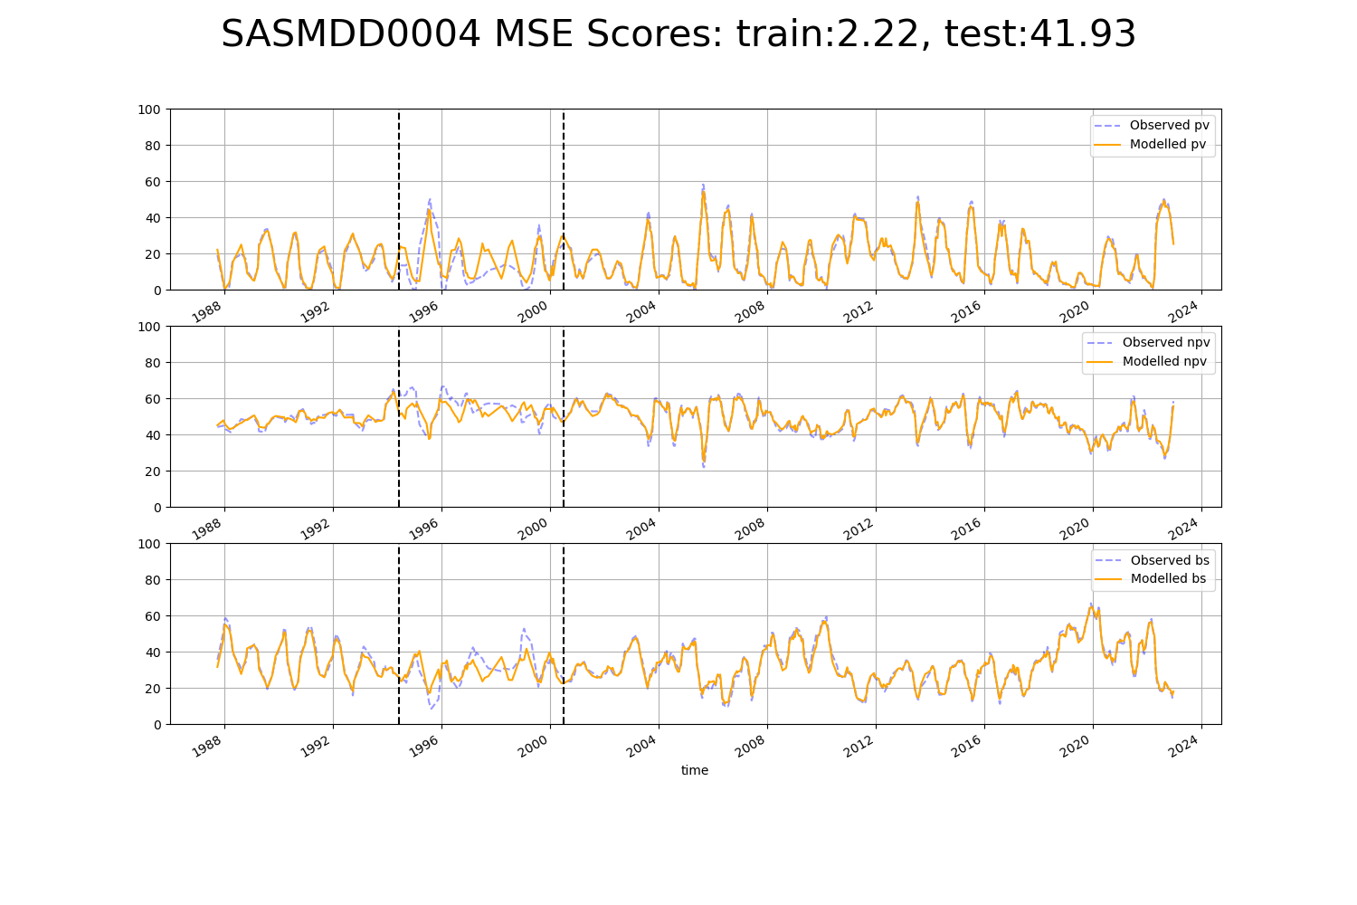

# SASMDD0011

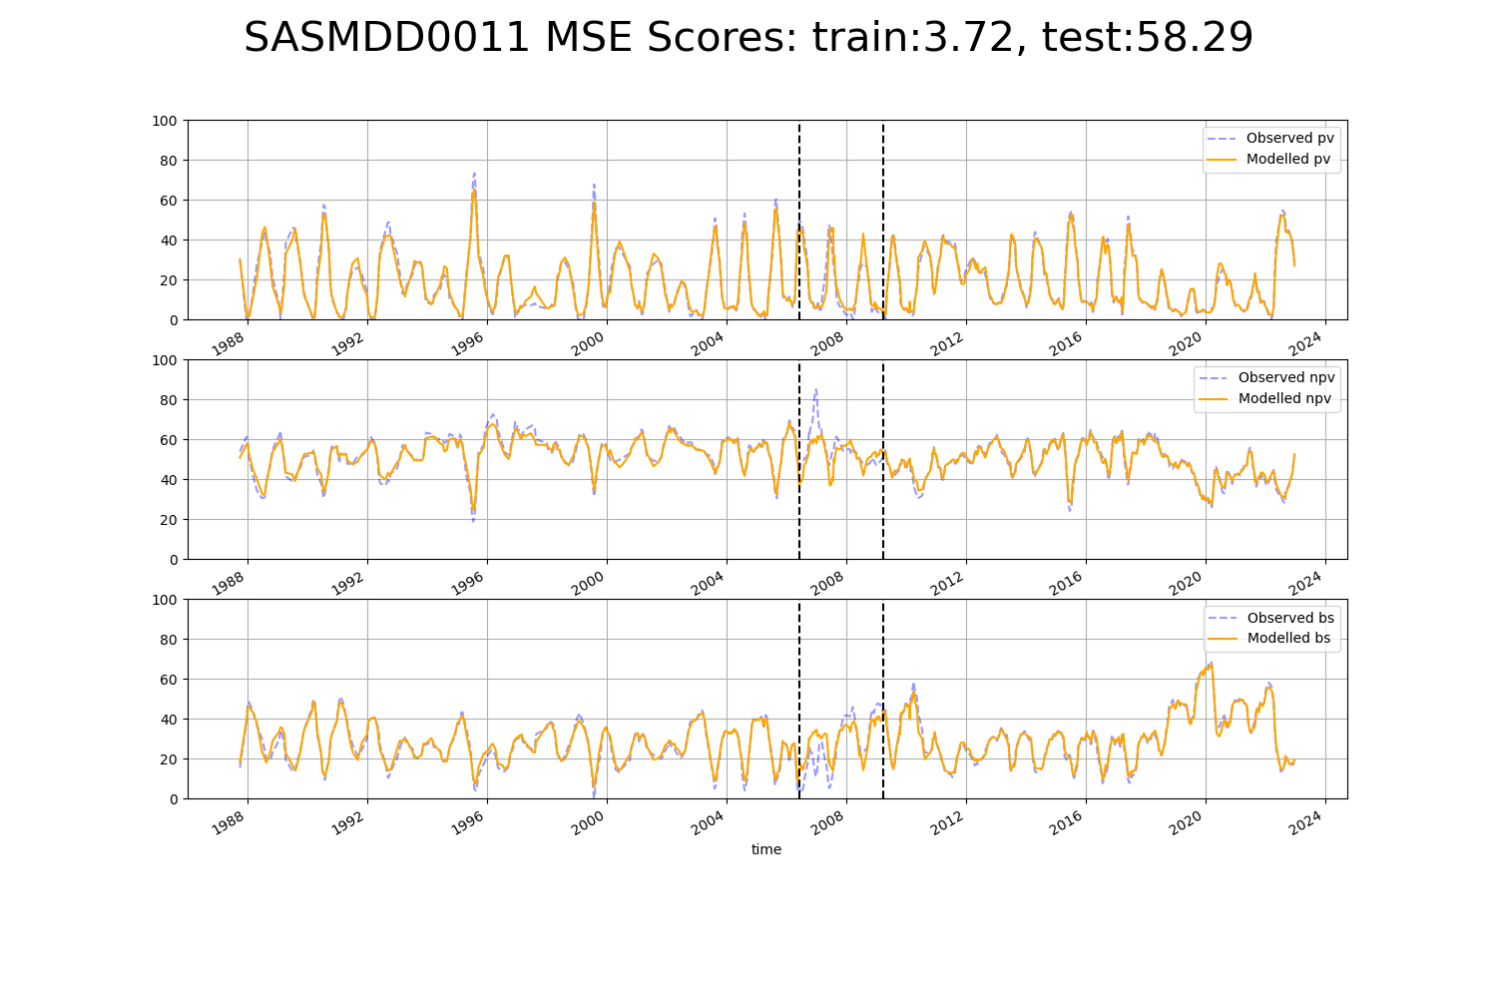

# SASRIV0001

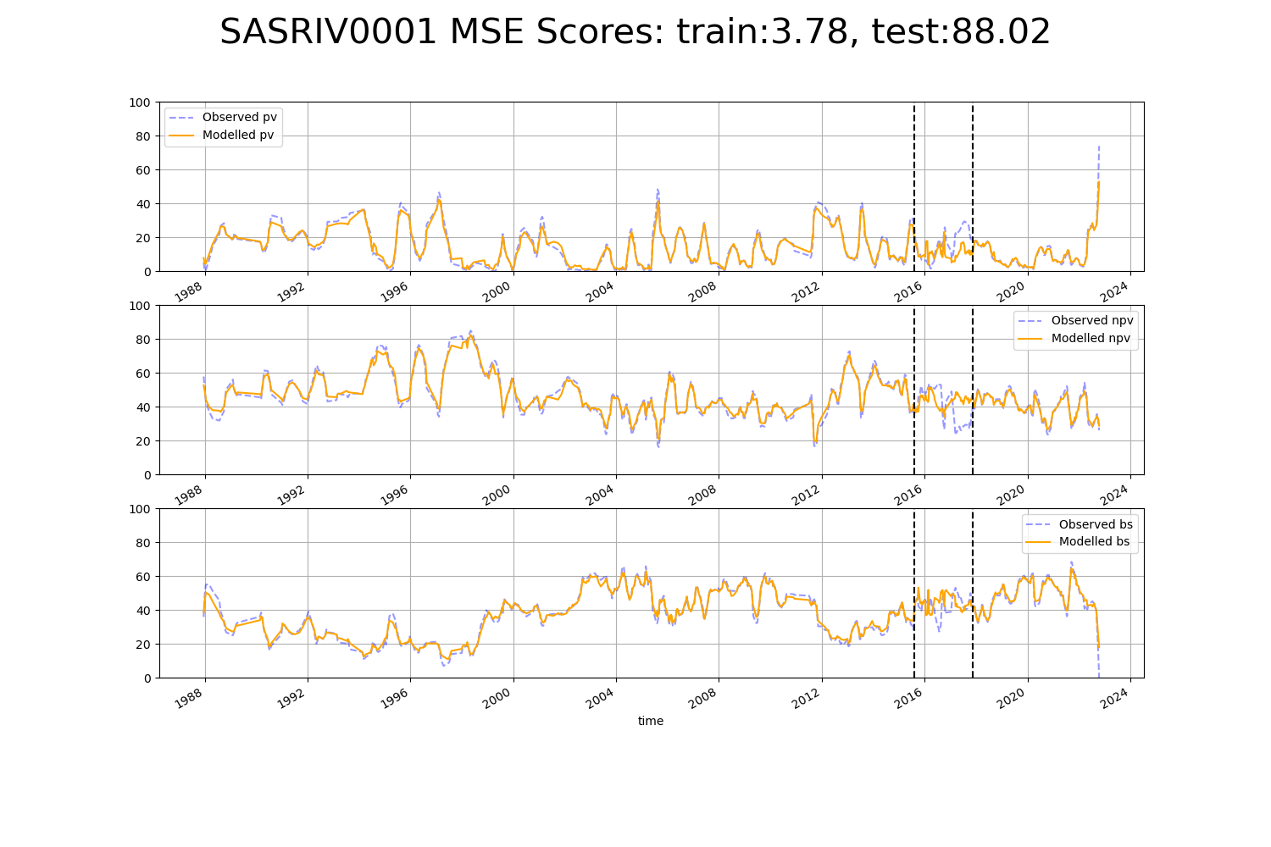

# SASRIV0002

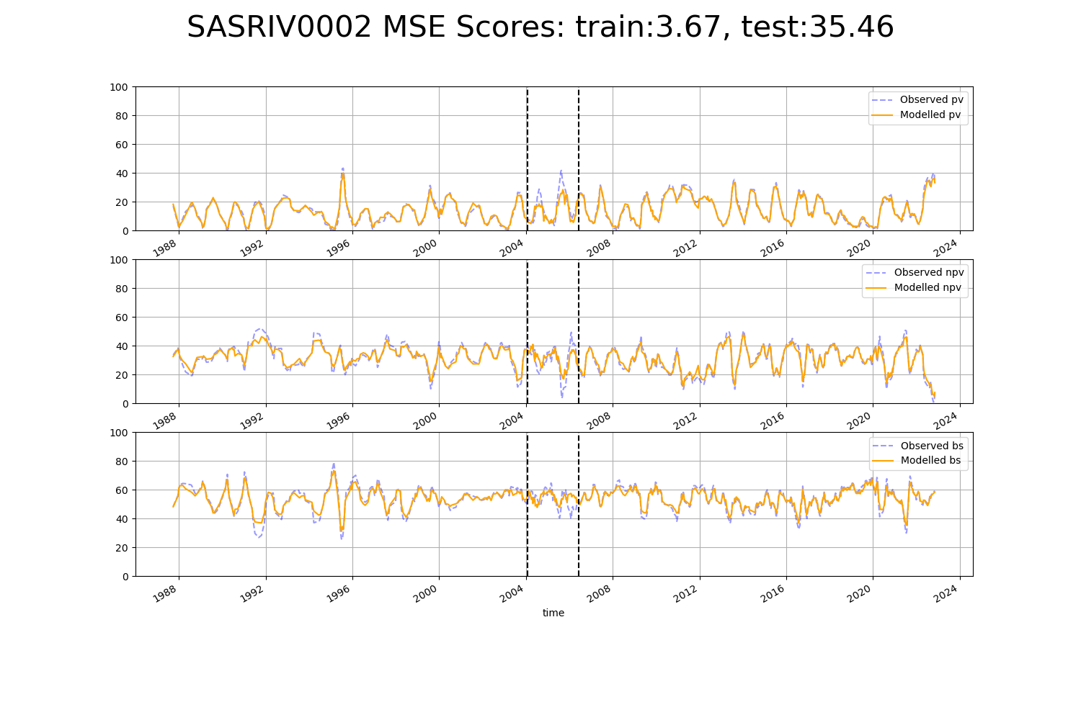

# SATFLB0024

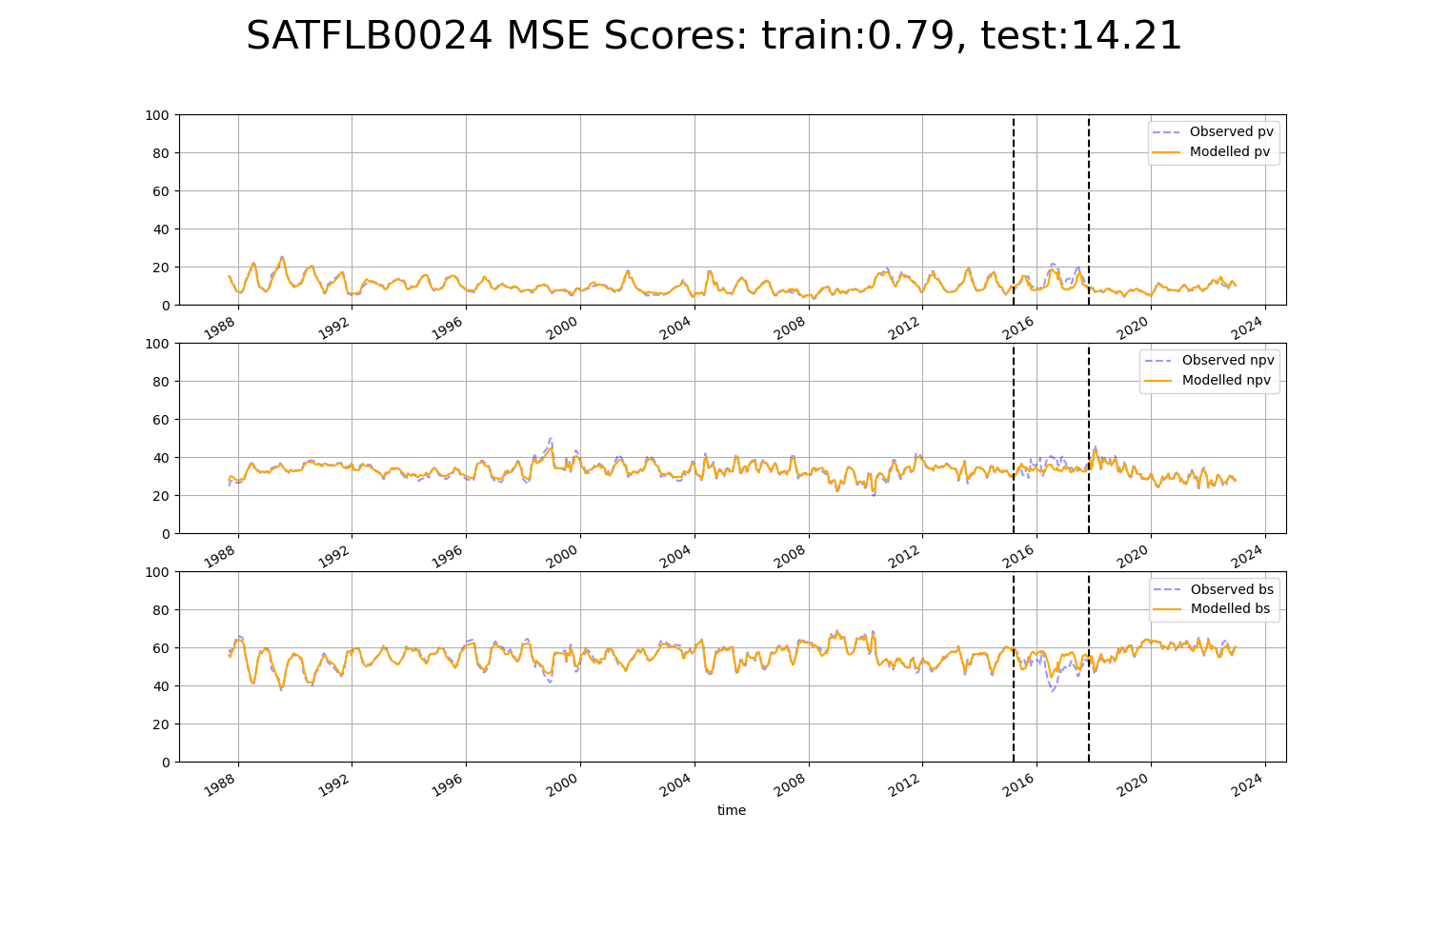

# SATSTP0002

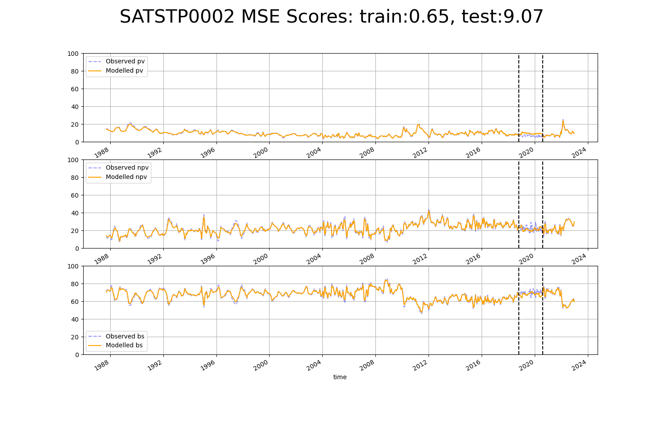

# VCAMDD0001

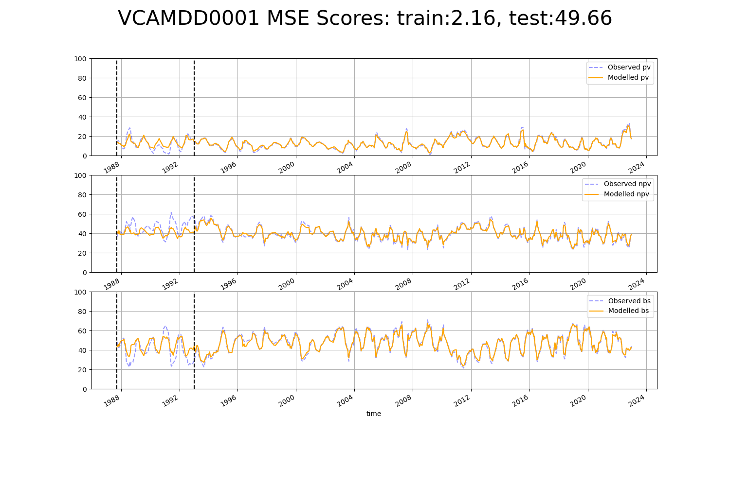

# VCAMDD0002

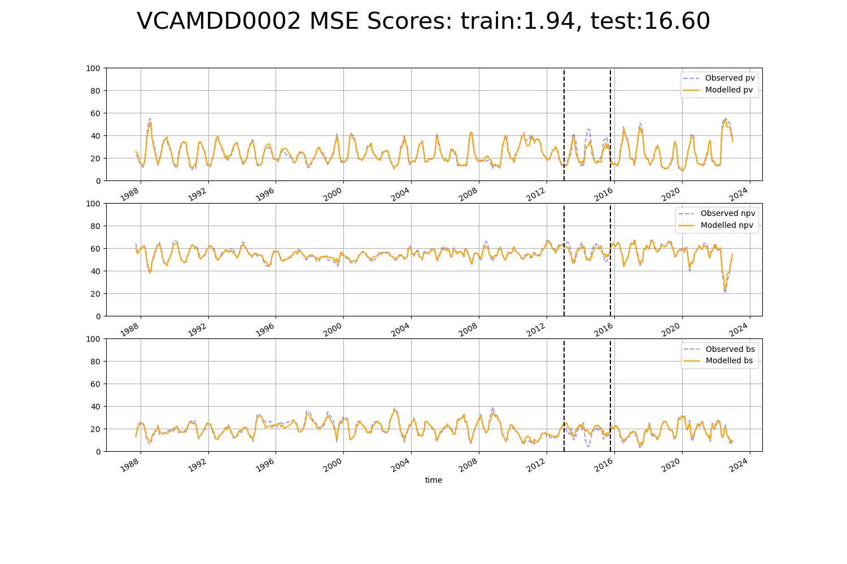

# WAACAR0001

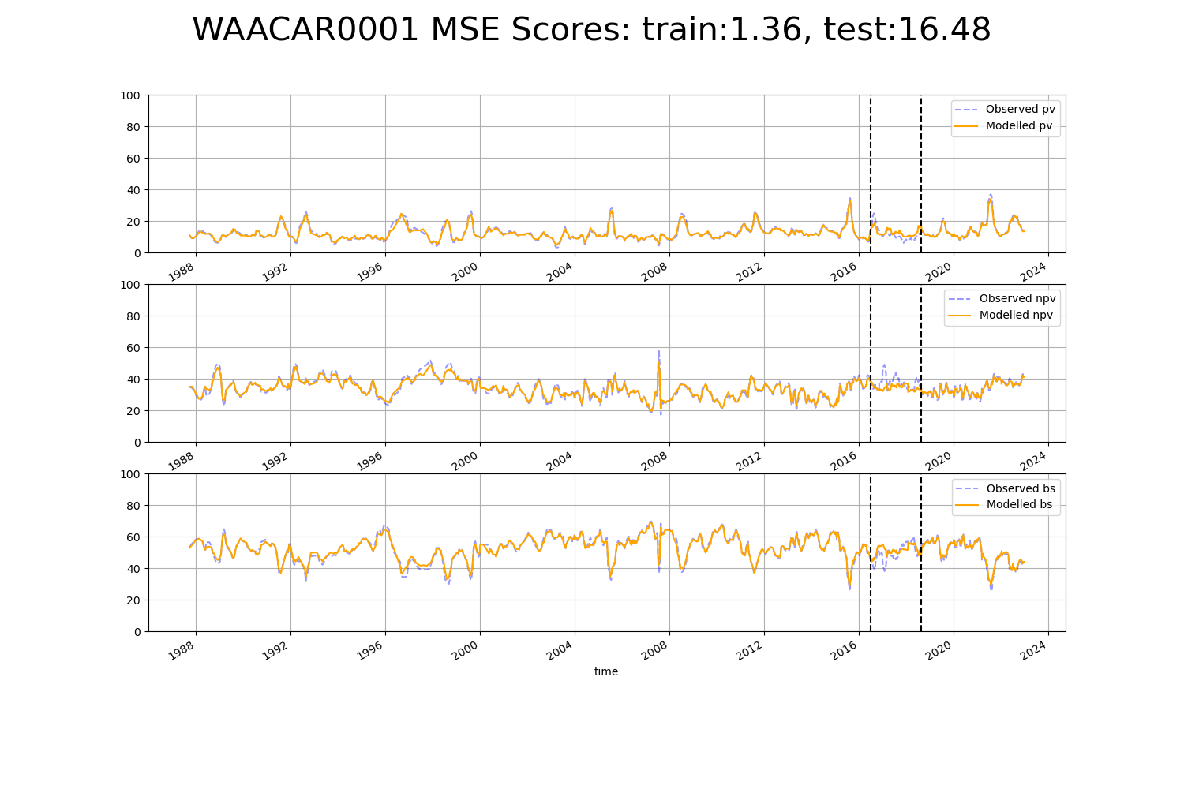

# WAACAR0004

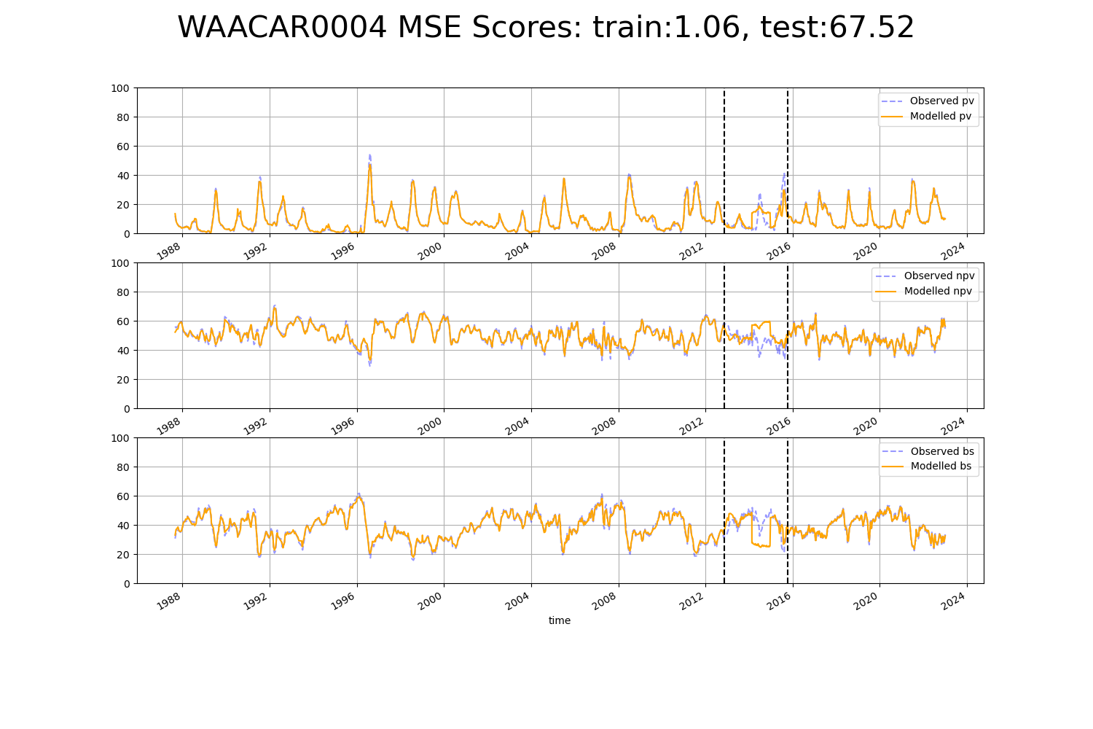

# WAACOO0030

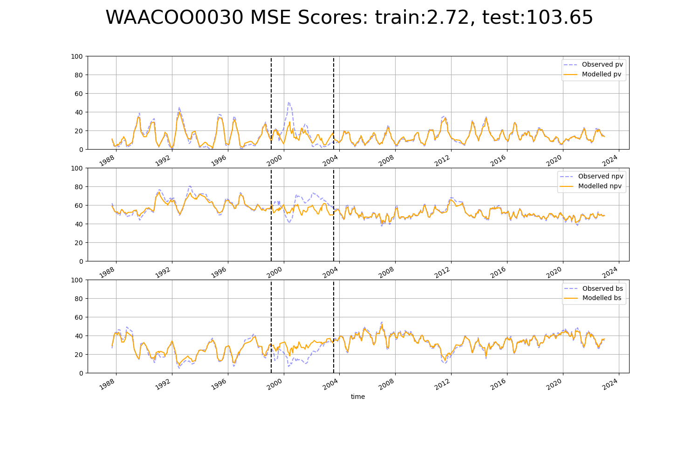

# WAADAL0003

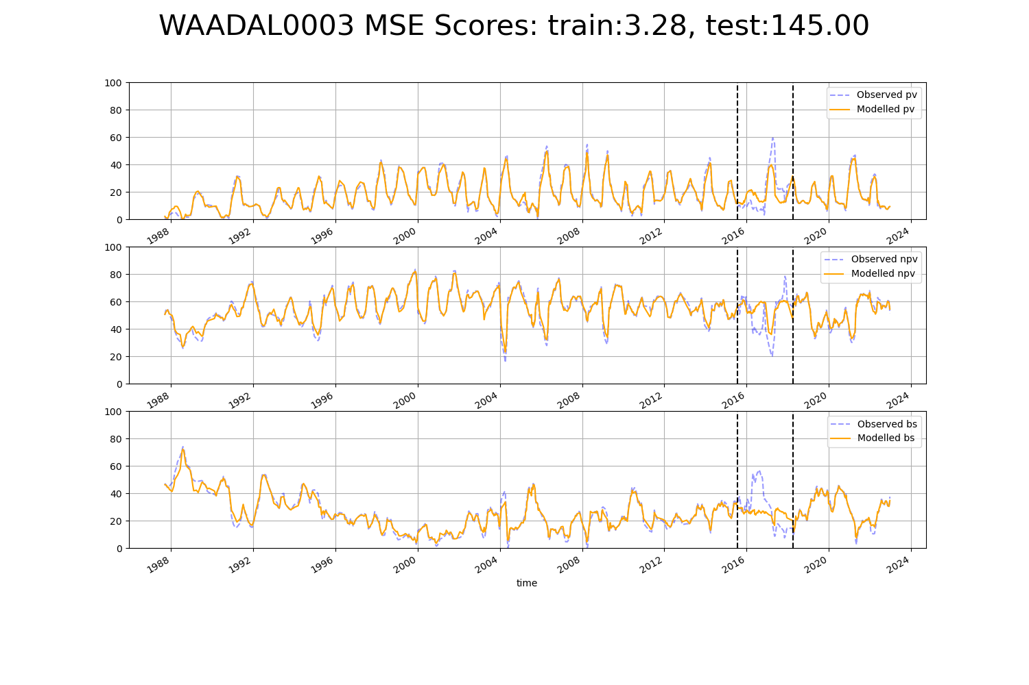

# WAANUL0001

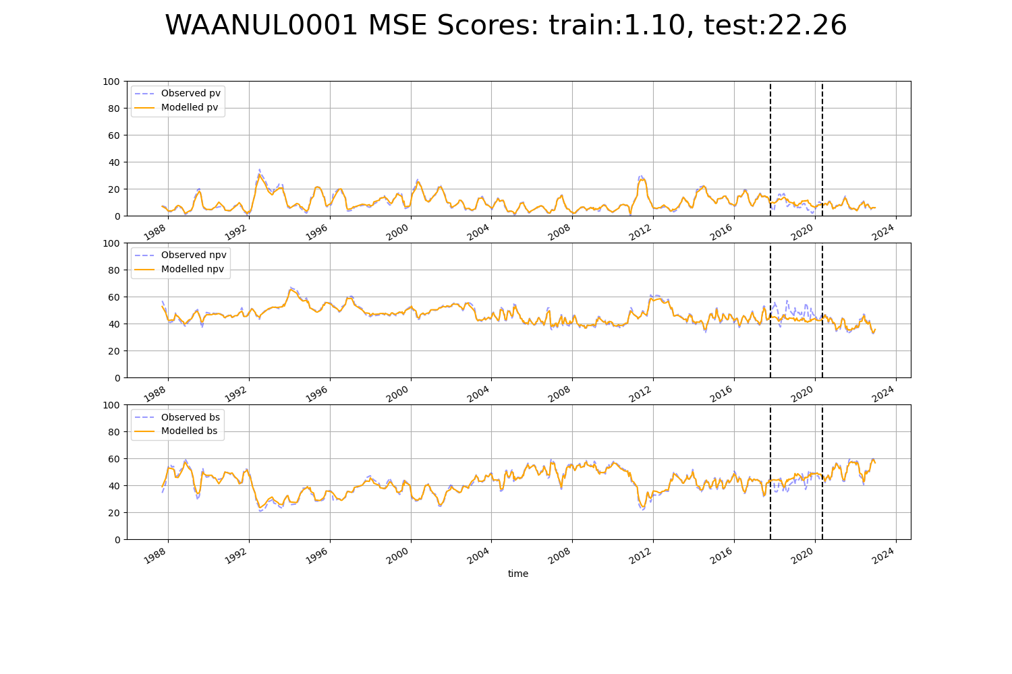

# WAANUL0003

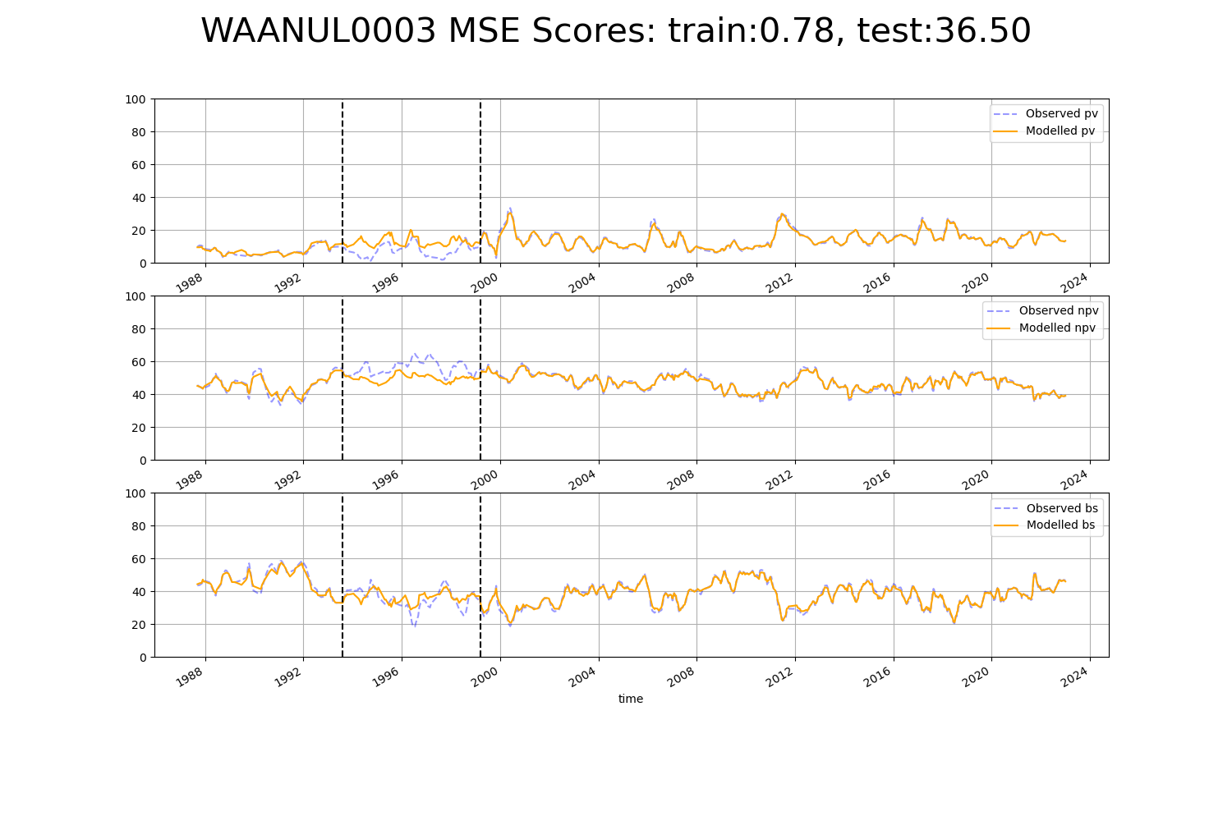

# WAANUL0004

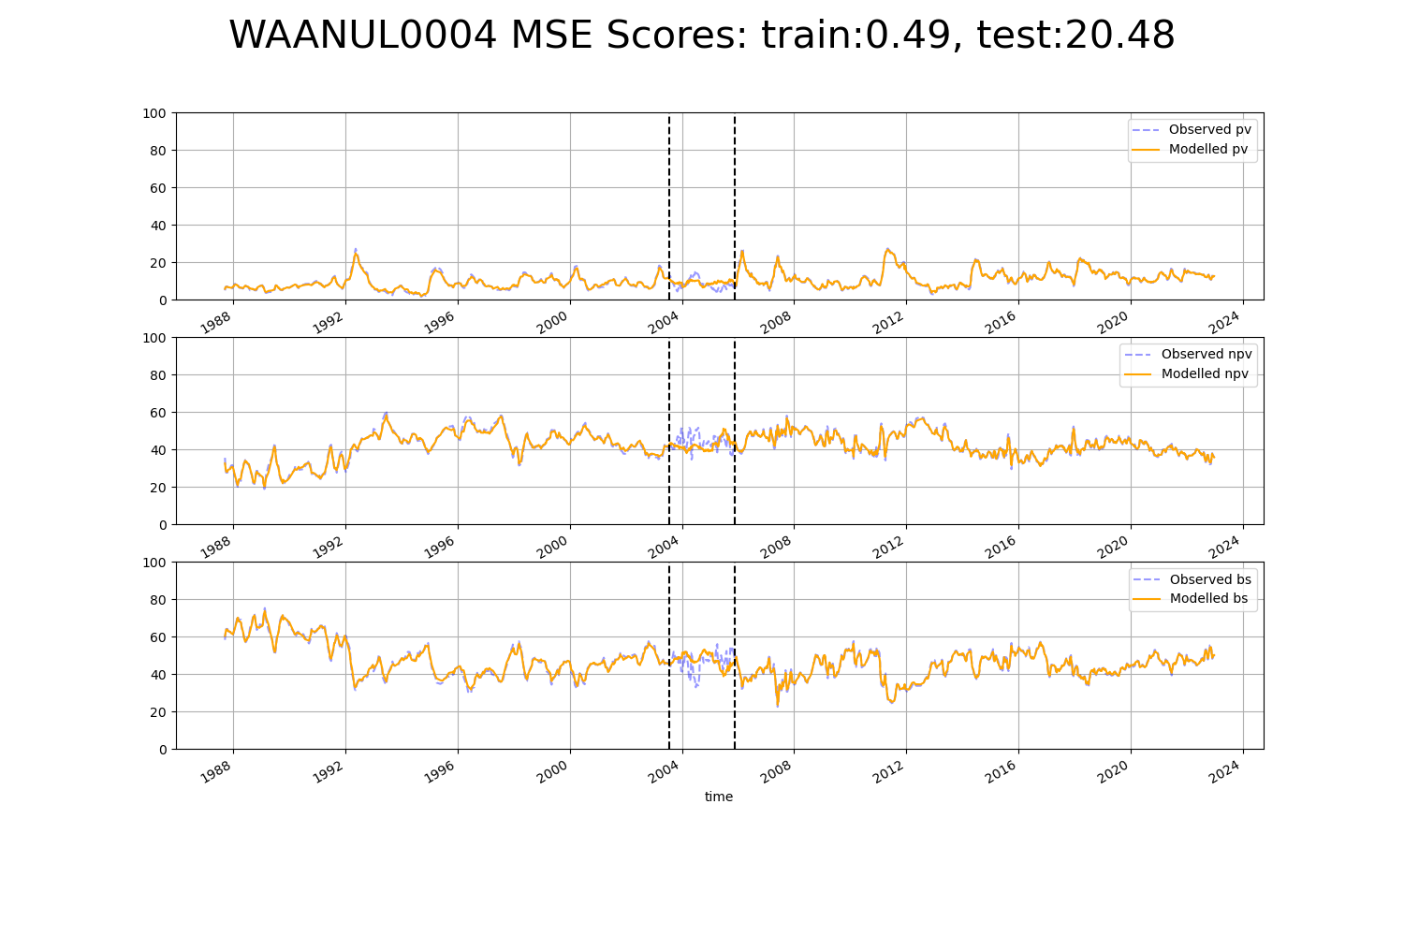

# WAANUL0008

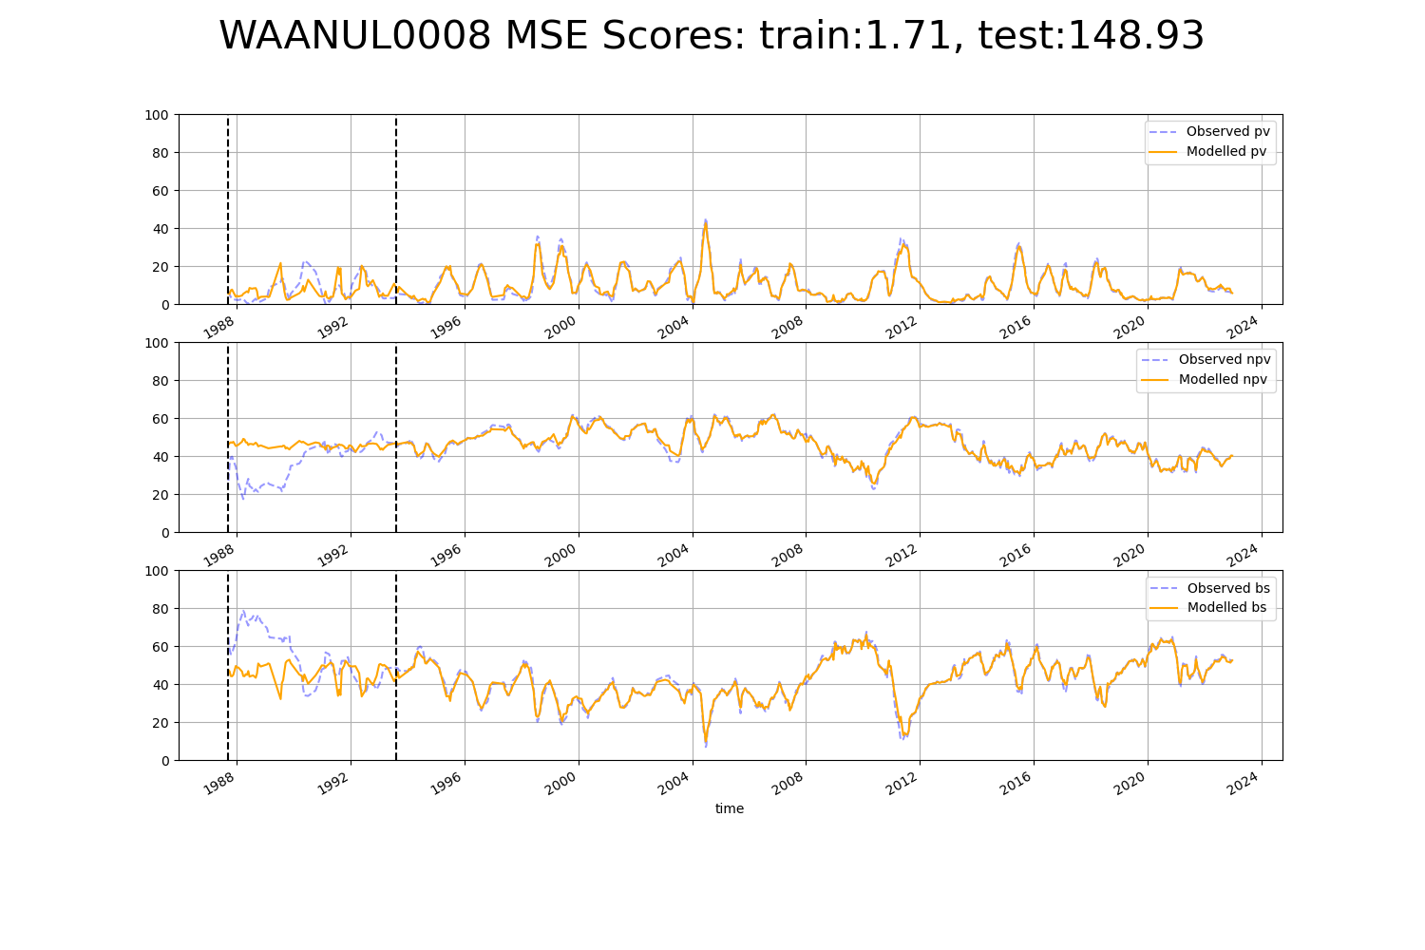

# WAANUL0009

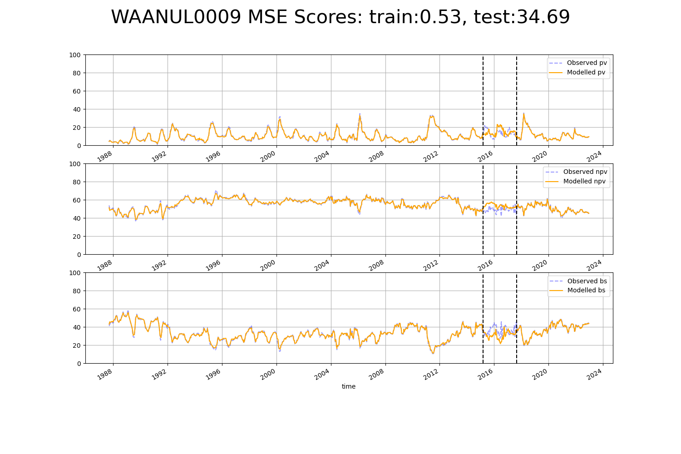

# WAAPIL0026

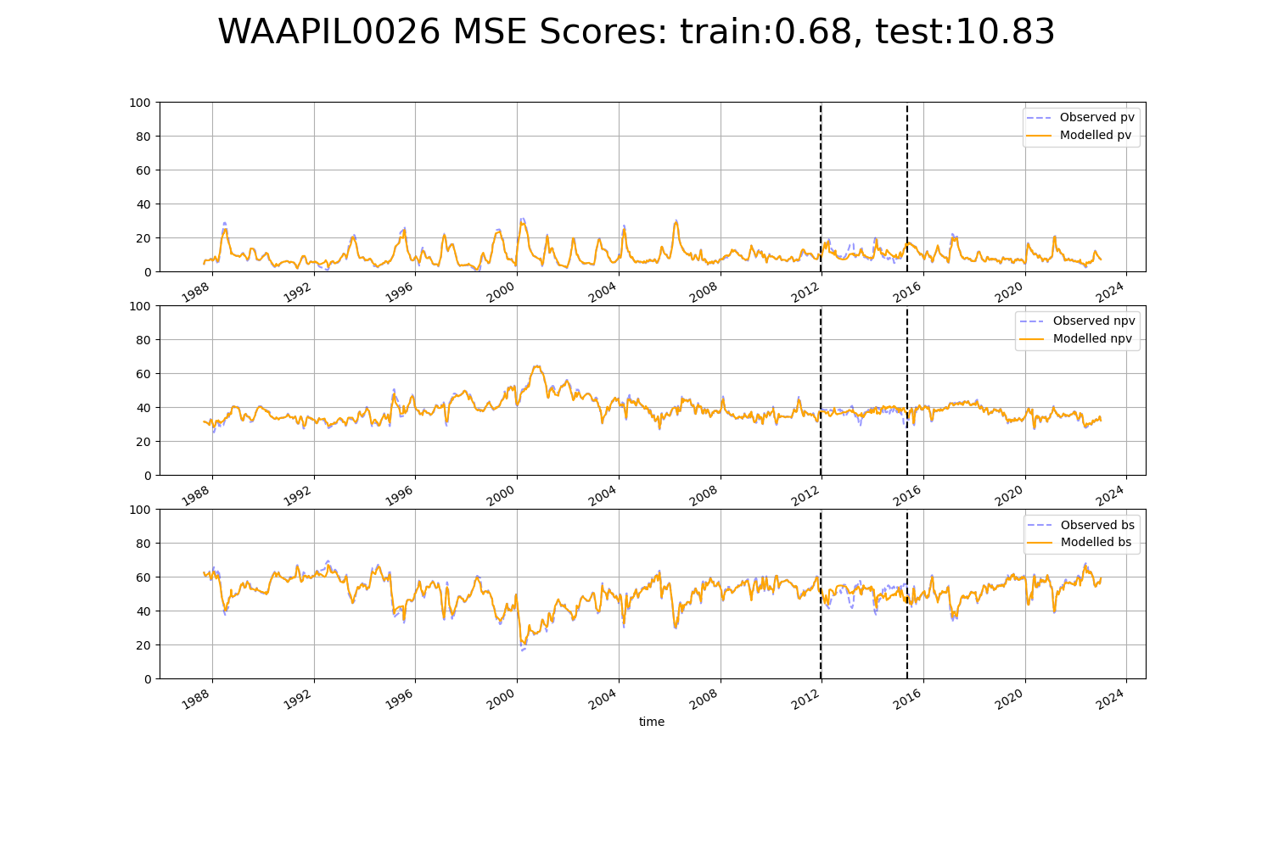

# WAGCOO0004

